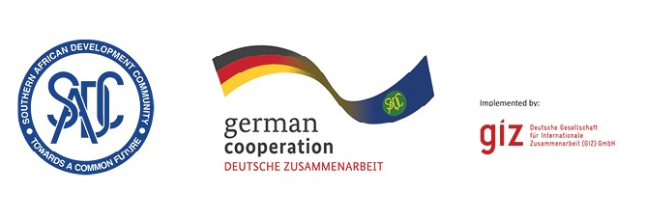

CALL FOR EXPRESSION OF INTEREST TO ATTEND

Pharmaceutical Value Chain B2B Event – Lusaka (Zambia 15 – 16 October 2025)

The Southern African Development Community (SADC) continues to advance its regional industrialisation agenda under the SADC Industrialization Strategy and Roadmap (2015-2063), which seeks to transform the region’s economies from resource-based to high productivity, value-added industrial hubs by enhancing regional and global value chains, strengthening intra-regional trade, positioning industries competitively in global markets, and fostering robust cross-border production networks. Anchored in this vision, a Business-to-Business (B2B) Event will be convened in Lusaka, Zambia to catalyse partnerships within the pharmaceutical value chain. This initiative aligns with the SADC Protocol on Health, which envisions a region that has harmonised pharmaceutical procedures, quality assurance and registration. In addition, the Protocol on Health calls for cooperation in production and procurement of medicines and health products. Aligned with the Health Protocol, the B2B aims to support private sector growth and regional integration through a responsive policy and regulatory environment that encourages productive public-private dialogue and enhances the movement of pharmaceutical inputs and products across borders of SADC Member States.

The Pharmaceutical Value Chain B2B Event provides a dynamic platform for stakeholders across the pharmaceutical value chain, including medicine and medical equipment manufacturers; distributors; professional associations; financial institutions (multilateral and national development banks, commercial banks, venture capital); and SADC central medical stores. The event is expected to establish and strengthen strategic linkages, exchange technical knowhow, and co-create actionable solutions addressing bottlenecks in production, quality enhancement, procurement and market access, technology adoption and distribution pharmaceuticals and health commodities in SADC region. Furthermore, the B2B Event will inform pharmaceutical industry stakeholders about the progress made in medicine and medical products regulations harmonization in the SADC region; the perspectives in SADC pooled procurement services; and the financing opportunities for further business development

The B2B Event will be organized in conjunction with Pharma Connect Africa Conference in Lusaka (Zambia) from 15 to 16 October 2025. It will include the following features:
- Thematic sessions: focused discussions on regulatory harmonisation, pooled procurement, and access to finance.
- Networking zones: structured matchmaking spaces for stakeholders to identify partnership opportunities.
- Information desks: on-site access to resources about SADC pharmaceutical initiatives, financing instruments, and access to finance

The SADC Secretariat invites qualified stakeholders who meet the requirements to express their interest to participate in the event. All participants from the Member States are welcome to attend at their own cost. Sponsorship will be availed to a limited number of stakeholders that will apply and meet the criteria listed below. The sponsorship package will include transport, accommodation, and meals for selected participants. Selection will ensure an equitable representation across Member States participating in the pharmaceutical value chain. The selection of the companies to sponsor and to invite to the event will be based on the following criteria:

- Involvement in the pharmaceutical value chain
- Unique technical expertise / know how in the value chain (including but not limited to active pharmaceutical ingredient production)
- Existing or planned expansion plans to the regional markets
- Incorporated in one of the SADC member states
- Potential added value of the company to the event.
- Commitment to attend to the entire event.
- Demonstrated efforts to support gender equality and youth involvement — for example, by involving women and youth in leadership or technical positions, having a gender-inclusive business approach, or offering products or services that benefit women and youth or promote equal participation in the value chain

The evaluation weights for the applications are as follow:
- Relevance to the event (30%)- alignment of participant to event’s theme.
- Technical / know how added value of the company (30%)
- Contribution potential (20%)- company relevance for regional networking.
- Diversity and inclusion (20%)- gender, youth, country

Submission deadline

All stakeholders from the SADC region (self-funding and sponsorship applicants) interested in participating in the B2B event are invited to submit their intention to participate.

Submission of intention to participate, with the subject matter: “Call for intention to participate, Ref “Pharmaceutical Value for the B2B Event” must be sent to: cesare.events@giz.de or uploaded to the event website:
https://cesareprivatenetworking.org/ by 17 September 2025, 2300hrs.

Please note that documents received after the stipulated time and date will not be accepted.

Stakeholders that have expressed their interest to attend the B2B event will be notified and receive further details of the event.

