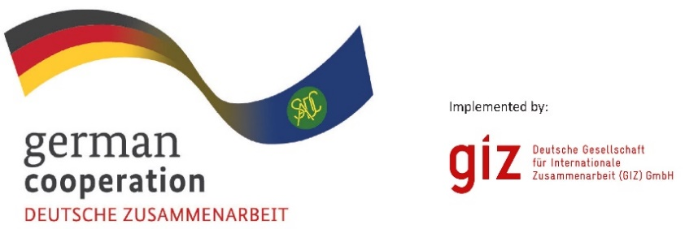

**CALL FOR EXPRESSION OF INTEREST**

**Leather Value Chain B2B Workshop**

***Bulawayo, Zimbabwe***

***22 to 24 July 2025.***

The Southern African Development Community (SADC) continues to advance its regional industrialisation agenda under the SADC Industrialization Strategy and Roadmap (2015– 2063), which seeks to transform the region’s economies from resource-based to high- productivity, value-added industrial hubs by enhancing regional and global value chains, strengthening intra-regional trade, positioning industries competitively in global markets, and fostering robust cross-border production networks. Anchored in this vision, a Business-to- Business (B2B) Workshop will be convened to catalyse partnerships within the leather value chain. This initiative aligns with the SADC Leather Regional Model Policy Framework, which envisions a competitive and integrated leather sector driving socio-economic transformation through heightened value addition, market integration, and sustainability. Aligned with the Model Policy Framework’s objectives, the B2B aims to support private sector growth and regional integration through a responsive policy and regulatory environment that encourages productive public-private dialogue and enhances the movement of leather inputs and products across borders. The B2B event will be hosted in Bulawayo, Zimbabwe, from 22 to 24 July 2025.

The Leather Value Chain B2B Workshop provides a dynamic platform for stakeholders across the leather value chain, including raw material suppliers, tanneries, manufacturers, technology providers, financiers, and distributors to establish strategic linkages, exchange technical know- how, and co-create actionable solutions addressing bottlenecks in production, quality enhancement, market access, and technology adoption. Special emphasis is placed on modernising tanning practices, fostering cleaner production techniques, harmonising quality standards, and strengthening institutional frameworks, which are underscored in the Leather Regional Model Policy Framework.

The B2B Workshop will have the following features:

* **Thematic Sessions**: Deep dives into challenges and opportunities across the value chain, focusing on modernisation of tannery infrastructure, sustainable practices, quality certification, and intra-regional trade facilitation.
* **Breakout Groups**: Interactive discussions targeting specific value chain components—tanning innovations, machinery and equipment advancements, skills development, and market diversification strategies.
* **Industry Tours**: Exposure to best practices in leather processing and manufacturing within the host country.
* **Networking Spaces**: Facilitated matchmaking for investment, technology transfer, and partnership-building.

The SADC Secretariat invites qualified stakeholders who meet the following requirements to express their interest in participation in the event: All participants from the Member States are welcome to attend at own cost

1. **Operational Base**: Companies/organisations domiciled and operating within the SADC region.
2. **Value Chain Engagement:** Actively involved in the Leather Value Chain
3. **Company Profile:** Ability to provide a company/organisation profile detailing the organisation’s history, core activities and technical abilities.
4. **Expansion Strategy:** Demonstrated current or planned expansion into regional markets, including organisations seeking to extend their services or service provision across the region.
5. **Innovation/Uniqueness:** A demonstrable unique innovation, specialisation or technical contribution to the leather value chain, e.g., alternative tanning technologies, modern livestock husbandry methods including feedlots, modern branding methods; modernisation and harmonisation of livestock Identification and Traceability Systems; effluent treatment and chrome recovery and innovative production of traditional leather products) machinery and equipment suppliers.
6. **Motivation Statement**: A clear motivation statement outlining the reason for

attending the B2B workshop, highlighting expected contributions and anticipated benefits.

1. **Commitment:** Availability to attend and engage fully in all workshop activities over the entire duration of the event

Sponsorship will be availed to a limited number of stakeholders that will apply and meet the criteria listed below. The sponsorship package will include transport, accommodation, and meals for selected participants, with a focus on ensuring equitable representation across Member States participating in the leather value chain. The following evaluation criteria will be applied:

Sponsored applicants will be evaluated based on:

* + **Relevance and Alignment (50%):** The applicant’s alignment with the workshop’s objectives and thematic focus.
  + **Technical Contribution (20%):** Potential to contribute substantive expertise, case studies, or innovations.
  + **Diversity and Inclusion (20%):** Representation of gender, youth, and geographical diversity.
  + **Knowledge Sharing and Implementation Plan (10%):** A clear strategy for disseminating workshop learnings and best practices to stakeholders within the applicant’s country and for implementing agreed B2B actions post-event.

**Submission deadline**

All stakeholders from the SADC region (self-funding and sponsorship applicants) interested in participating in the B2B event are invited to submit their Expression of Interest.

Submission of relevant documents as stipulated above (1-7), with the subject matter: “***Call for Expression of Interest, Ref “Leather Value for the B2B Workshop***” must be sent to: [BW_Quotation@giz.de](mailto:BW_Quotation@giz.de) by 22nd June 2025, 2300hrs.

**Please note that documents received after the stipulated time and date will not be accepted.**

**Stakeholders that have expressed their interest to attend the B2B event will be notified and receive further details of the event.**