

**Link for Downloading Complete Tender Documents**

**For**

**PROPOSED SADC STANDBY FORCE REGIONAL LOGISTICS DEPOT AT RASESA, BOTSWANA, TO ATTAIN INITIAL OPERATING CAPABILITY**

**Tender No.: SADC/3/5/1/87**

**Issued on: 4th DECEMBER 2023**

**Link**: [**https://collab.sadc.int/s/zQbk5meSGen6LAs**](https://collab.sadc.int/s/zQbk5meSGen6LAs)

***See below for Instructions for downloading the documents***

**Instructions for downloading tender documents**

1. **Click the link provided above or copy link and paste in address bar of any web browser and hit ‘Enter’**
2. **The following window will open:-**

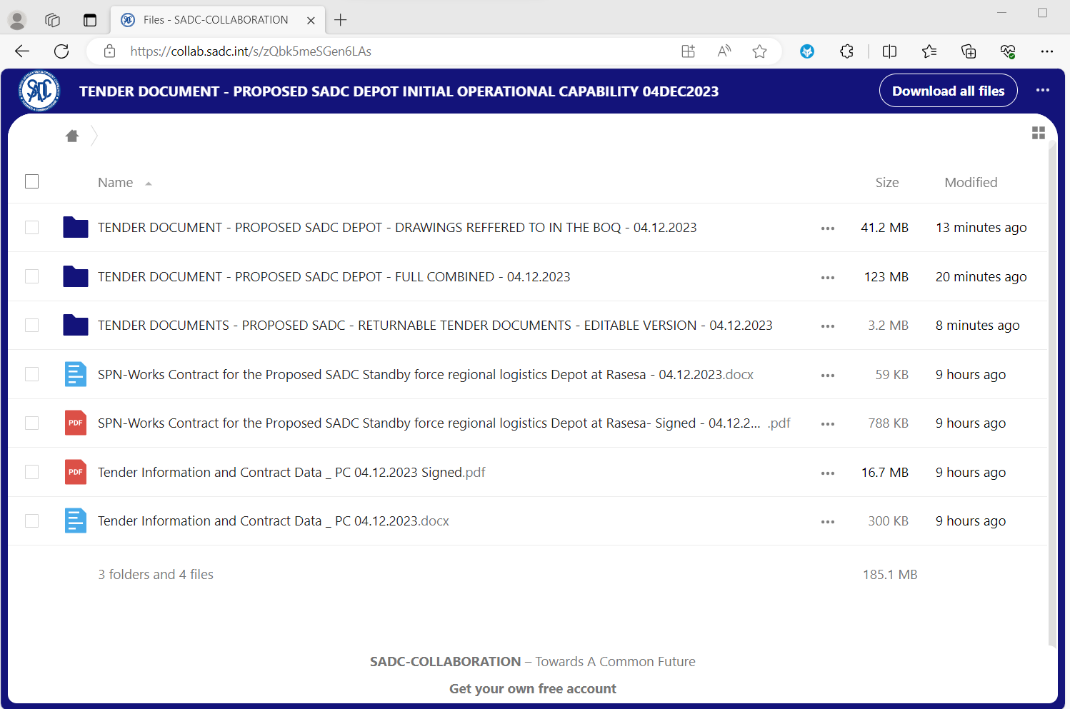

1. **Right Click on each document or folder and click on the word ‘Download’ that pops up as per below:-**

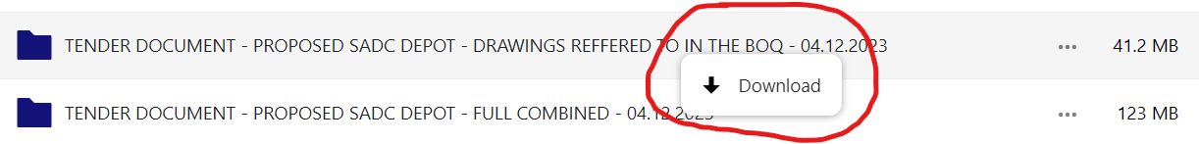

1. **Repeat the same for each document or folder until you download all documents.**

* **End -**