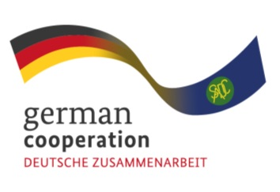

Invitation to tender advert: 83447630
Consultancy to conduct a Needs Assessment for the SADC Industrial Pharmacy Fellowship programme
The Southern African Development Community (SADC) Secretariat, the European Union (EU) and the German Federal Ministry for Economic Cooperation and Development (BMZ) are jointly supporting the “COVID-19-relevant Medical and Pharmaceutical Products” (CMPP), the Antiretroviral (ARV) and Leather regional value-chain (RVC) projects. These RVCs are part of the Joint Action “Support towards Industrialization and the Productive Sectors in the SADC region (SIPS) project. The overall objective of this regional assignment is to support the development of a SADC Regional Industrial Pharmacy Fellowship to increase the availability of skilled industrial pharmaceutical personnel in the SADC region.

Findings from the inception phase of the Joint Action SIPS revealed that the SADC region lacks skilled personnel for pharmaceutical production and needs to build capacity. To address this, the Joint Action aims to enhance subject matter knowledge skills by facilitating the development of industry knowledge clusters between the private sector and academic / training institutions within the antiretroviral (ARV) value chain through academic initiatives such as developing a fellowship program. For this assignment, the consultant will conduct a needs assessment for the SADC Industrial Pharmacy Fellowship Program (IPFP) in coordination with the Joint Action SIPS, universities and training institutions in South Africa, Zambia and Tanzania, as well as regional pharmaceutical manufacturing companies, regional associations and the SADC Secretariat.

It is against this backdrop, that The Joint Action SIPS invites competent and qualified companies based in Africa continent to apply for this assignment (Continent of Africa tender).The selected service provider will enter into a contract with GIZ.

Submission deadline
Kindly submit your bid, comprising (i) a technical offer and (ii) price offer by 8th October 2023, 23.00hrs / 11p.m by email submission at BW_Quotation@giz.de.
Please note that tender bids received after the stipulated time, date will not be accepted.

