

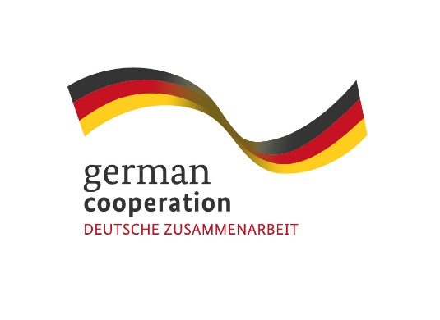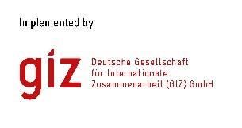

|  |
| --- |
| **Contract 83442885**  **Call for Proposals:**  **Support the data capture and evaluation of NEW project indicators** |

The Deutsche Gesellschaft für Internationale Zusammenarbeit (GIZ) GmbH, through its project “Supporting sustainability aspects in the implementation of EU Economic Partnership Agreements”, commissioned by the German Federal Ministry for Economic Cooperation and Development (BMZ), cordially invites interested and qualified consulting firms to send in a proposal:

**FOR ASSISTING THE NEW PROJECT IN ITS EVALUATION AND EVIDENCE (DATA) CAPTURE FOR TWO (2) OUT OF ITS FIVE (5) MODULE INDICATORS.**

Following the signature of the Economic Partnership Agreement (EPA) between six (6) SADC Member States (Botswana, Eswatini, Lesotho, Mozambique, Namibia and South Africa) on the one hand, and the European Union (EU) on the other and its provisional application since October 2016, GIZ commenced a global project operating under the title “Supporting sustainability aspects in the implementation of EU Economic Partnership Agreements (NEW)”. The overall objective of the project is to foster EPA implementation by regional organisations, their member states, the private sector and civil society in a way that supports sustainable development. Its geographical focus is on Southern Africa (SADC EPA), Eastern and Southern Africa (ESA) and the Caribbean (CARIFORUM EPA).

The assignment aims to assist the NEW project in its evaluation and evidence (data) capture for two (2) out of its five (5) module indicators (MI). These are NEW’s module indicator 3 “*Thirty of 50 surveyed representatives of national agencies from the SADC region, who are responsible for implementing EPA provisions, have presented specific examples that demonstrate how their organisation’s contribution to sustainable implementation of the EPAs has changed”* and module indicator 5. *“Thirty of 40 surveyed participants in cross-regional exchange formats on sustainable implementation of EPAs have each provided one example that demonstrates how they have used the knowledge acquired at the events to contribute towards realising potentials of the EPAs or averting risks”.*

**Submission deadline**

Kindly submit your bid, comprising (i) a technical offer and (ii) price offer no later than 18th September 2023, 2300hrs/11pm to **BW_Quotation@giz.de**. Please note that tender bids received after the stipulated time and date will not be accepted.

**Please note that this is a regional tender for SADC region-based companies.**