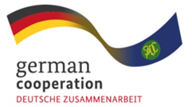
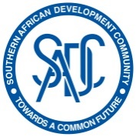
Implemented by:

ADVERT FOR THE JOINT ACTION SIPS ONLINE BUSINESS MANAGEMENT SKILLS TRAINING COURSES
The Joint Action "Support towards Industrialisation and Productive Sectors" (SIPS) in the Southern African Development Community (SADC) region, is a SADC Secretariat programme supported by the European Union (EU) and the German Federal Ministry for Economic Cooperation and Development (BMZ) to facilitate the expansion of regional value chains and promote dialogue between the private and the public sector. The Joint Action SIPS is part of the BMZ-commissioned programme "Cooperation for the Enhancement of (SADC) Regional Economic Integration" (CESARE). The objective of the Joint Action SIPS is to contribute to the SADC industrialisation and regional integration agenda through improving the performance and growth in the Anti-retroviral (ARV) value chain and the COVID-19-relevant medical and pharmaceutical products value chain (CMPP).

As part of the activities in the ARV and CMPP value chains, the Joint Action SIPS is offering virtual short courses on Business Management Skills Training on Junior Management Level. The courses are covering relevant topics, such as Quality Management, Value Chain Analysis, Market Access Management, Human Resource Management and many more.

The Joint Action SIPS would like to invite companies/businesses who are operating in the ARV and CMPP space to nominate up to 4 Junior Management employees from their company for the upcoming short courses.

The courses are virtual, free of charge, and will be taught in English.
Each day, different topics will be taught.

Dates:

1. 14.08.2023 - 18.08.2023 (5 days)
2. 28.08.2023 - 01.09.2023 (5 days)
3. 11.09.2023 - 15.09.2023 (5 days)

Time: Every day from 8:00 am – 4:30 pm CAT (Central Africa Time)

Registration: https://tinyurl.com/SIPSBSM
Deadline for application: 31st July 2023, 12:00 PM CAT (fill out and submit the online application)
If you have any questions, concerns, or challenges, please contact us at: ITsupportSIPS@giz.de

