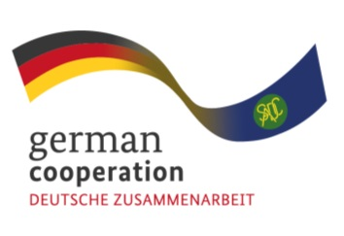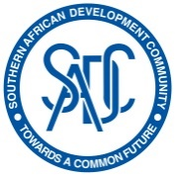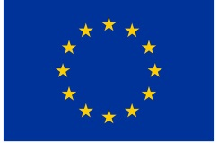

**CALL FOR EXPRESSION OF INTEREST**

**Good Manufacturing Practices (GMP) capacity building in the SADC Region**

The Southern African Development Community (SADC) Secretariat, the European Union (EU) and the German Federal Ministry for Economic Cooperation and Development (BMZ) are jointly supporting the “COVID-19-relevant Medical and Pharmaceutical Products” (CMPP), the Antiretroviral (ARV) and Leather regional value-chain (RVC) projects. These RVCs are part of the Joint Action “Support towards Industrialization and the Productive Sectors in the SADC region (SIPS) project

The overall objective of this assignment is to engage a consulting company in Good Manufacturing Practices (GMP) to provide GMP capacity building to selected pharmaceutical manufactures, regulatory authority and industrial pharmacy students. The contractor shall provide two full-time experts and two short-term expert pool with pharmaceutical GMP audit experience for the duration of the assignment

The Joint Action SIPS aims to strengthen private sector and regulatory authority in adherence to WHO Good Manufacturing Practice adherence (GMP) key principles. Adherence to GMP is essential to ensure quality, safety and efficacy of medicinal products. However, due to the lack of financial, technical and human resource capacities, pharmaceutical manufacturers in developing countries are often overwhelmed by the vast array of GMP requirements and therefore fail to operate in line with such internationally acceptable standards, such as the WHO GMP standard. Findings from SIPS inception reports that most companies in the SADC region are facing challenges with the implementation of cost intensive GMP requirements.

The approach to implementing GMP capacity building entails involvement of local manufacturers and National Medicines Regulatory Authority (NMRA) from the onset to ensure a transparent and successful project. The key activities in implementation of GMP capacity building are:

1. Baseline assessment of facilities through physical inspection or review of last inspection report or plans for the new infrastructure or infrastructure adaptations.
2. Provision of tailor-made consultancy on corrective and preventative action (CAPA) intervention through CAPA clinics
3. Support selected API manufacturer with technical support to draft and prepare documentation for WHO Pre-qualification (PQ) inspection

Eligible bidders must demonstrate the following:

1. Average annual turnover of EUR50,000.00 over the last 3 financial years
2. Average of 2 employees and managers over the last 3 calendar years
3. At least 2 reference projects on Good Manufacturing Practices (GMP) capacity building in Africa continent in the last 3 years
4. Reference projects with minimum commission value of EUR 10,000,00
5. Demonstrable the following technical experience.
   1. Experience in Industrial Pharmacy
   2. Conducting Good Manufacturing Practices (GMP) audits/assessments
   3. Preparing companies for WHO PQ GMP audits
   4. Designing and conducting GMP trainings
   5. Establishing GMP quality systems

The Joint Action SIPS is therefore inviting interested service providers from the **African continent** to submit an expression of interest for the assignment.

Interested parties wishing to participate in this preliminary selection to submit their documents as above points 1 to 5 subject matter: “***Call for Expression of Interest, Ref* Good Manufacturing Practices (GMP) capacity building in the SADC Region** **No.** 83440330***”*** to: BW_Quotation@giz.de latest by 18th July 2023 at 17:00hrs local time.