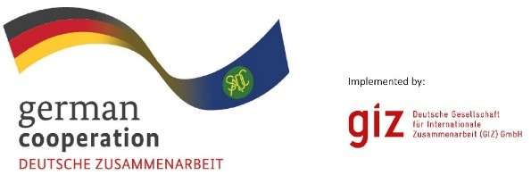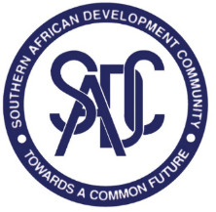

INVITATION TO TENDER ADVERT: 83440420
Review and updating of the Joint IWRM Strategy for the Rovuma/Ruvuma Watercourse
The Deutsche Gesellschaft für International Zusammenarbeit (GIZ) supports the SADC Water Division through the Transboundary Water Management (TWM) programme. The TWM programme supports the management of shared watercourses in southern Africa by promoting the effective implementation of the SADC Regional Strategic Action Plan on Integrated Water Resources Development and Management, Phase V (RSAP V).
The main objective of this assignment is to review and update the Joint Integrated Water Resources Management Strategy for the Rovuma/Ruvuma Watercourse. This will include an assessment of the state of the basin to update the basin monograph and inform development scenarios that map out and give recommendations for the review and updating of the IWRM strategy.
It is against this background that TWM is seeking the services of a consulting firm (registered company in one of the 16 SADC Member States).

Submission deadline and address:
Kindly submit your bid, comprising (i) Eligibility documents (ii) technical offer and (iii) price offer to BW_Quotation@giz.de no later than 9th July 2023 2300hrs /11pm local time

Please note that tender bids not received at the stipulated date and time will not be accepted.

