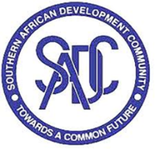

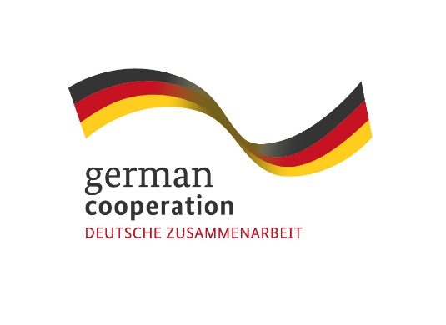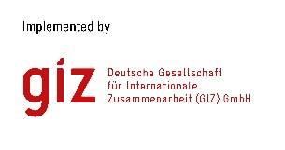

**Call for Proposals: Capacity Development for SADC EPA States’ Public Officials on Origin Cumulation under the EU-SADC EPA.**

**Contract 83440483**

The Deutsche Gesellschaft für Internationale Zusammenarbeit (GIZ) GmbH, through its project “Supporting sustainability aspects in the implementation of EU Economic Partnership Agreements”, commissioned by the German Federal Ministry for Economic Cooperation and Development (BMZ), cordially invites interested and qualified consulting firms to send in a proposal:

**FOR CAPACITY DEVELOPMENT FOR SENIOR PUBLIC OFFICIALS OF SADC EPA MEMBER STATES ON ORIGIN CUMULATION UNDER THE EU-SADC EPA.**

Following the signature of the Economic Partnership Agreement (EPA) between six (6) SADC Member States (Botswana, Eswatini, Lesotho, Mozambique, Namibia and South Africa) on the one hand, and the European Union (EU) on the other and its provisional application since October 2016, GIZ commenced a global project operating under the title “Supporting sustainability aspects in the implementation of EU Economic Partnership Agreements (NEW)”. The overall objective of the project is to foster EPA implementation by regional organisations, their member states, the private sector and civil society in a way that supports sustainable development. Its geographical focus is on Southern Africa (SADC EPA), Eastern and Southern Africa (ESA) and the Caribbean (CARIFORUM EPA).

The objective of this initiative is to build the technical capacities of officials of the six SADC EPA Member States in the operationalization of the implementation of the diagonal cumulation of origin provided for in the EU-SADC EPA so that the potential benefits of the Agreement are fully exploited.

**Submission deadline**

Kindly submit your bid, comprising (i) a technical offer and (ii) price offer no later than 26th June 2023 1700hrs /5pm to **BW_Quotation@giz.de.** Please note that tender bids received **after** the stipulated time, date will not be accepted.

**Please note that this is a regional tender for SADC region-based companies.**