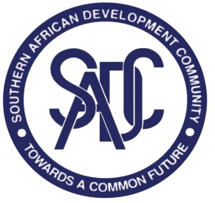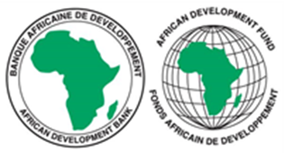
SOUTHERN AFRICAN DEVELOPMENT COMMUNITY (SADC) SECRETARIAT

RE-ADVERTISEMENT

REQUEST FOR EXPRESSIONS OF INTEREST (REOI)
(CONSULTING SERVICES- FIRM SELECTION)

CONSULTANCY TO DEVELOP A FRAMEWORK FOR BOTH CROSS-BORDER SETTLEMENT OF SECURITIES ON THE SADC RTGS, AND FOR REPORTING ON SUSTAINABILITY AND EQUALITY

PROJECT NAME: MACROECONOMIC STABILITY AND FINANCIAL INTERGRATION PROJECT IN THE SADC REGION

FINANCING AGREEMENT REFERENCE: 2100155041084

PROJECT ID NO.: P-Z1-KF0-067

DATE: 15 MAY 2023

- The Southern African Development Community (SADC) Secretariat has received financing from the African Development Fund towards the cost of the MACROECONOMIC STABILITY AND FINANCIAL INTERGRATION PROJECT IN THE SADC REGION and intends to apply part of the agreed amount for this grant to payments under the contract for CONSULTANCY TO DEVELOP A FRAMEWORK FOR BOTH CROSS-BORDER SETTLEMENT OF SECURITIES ON THE SADC RTGS, AND FOR REPORTING ON SUSTAINABILITY AND EQUALITY.

- The Macroeconomic Stability and Financial Integration project objective is to enhance macroeconomic stability and convergence in the SADC region and to support the development of integrated of financial markets in SADC, to facilitate the most efficient allocation of savings and investment.

- The overall objective of this consultancy assignment is to support the interconnectivity project between the 14 stock exchanges in the SADC region, which will result in the creation of a deeper and more integrated regional capital market

- The purpose of this assignment is to develop a policy framework that will enhance safety and efficiency of the SADC Regional Payments System in the region and a framework for reporting on sustainability and equity.

- The SADC Secretariat now invites eligible consulting firms to indicate their interest in providing these services. Interested consulting firms must provide information indicating that they are qualified to perform the services (i.e. description of similar assignments, experience in similar conditions and availability of appropriate skills among staff).

- The consulting firm must have an in-depth knowledge and experience in the development of payment systems laws and regulations and specifically the development of specifications for interoperable financial services.Relevant experience with development of laws and regulations in a similarly situated developing countries environment would be an advantage. The skills among the staff should include; Regulatory and Compliance Specialist with expertise in legal, supervisory and compliance matters who has experience in the financial industry as a regulator and a Sustainable Finance Specialist-EGS+ Financial Ecosystem Reporting Specialist who will support the process of developing the EGS+ tool kit for the capital Market in the region.

- Consultants may constitute joint-ventures to enhance their chances of qualification.

- Establishment of the short-list and the selection procedure shall be in accordance with the African Development Bank’s Procurement Policy for the Bank Group-funded Operations”, dated October 2015, which is available on the Bank’s website at http://www.afdb.org

- Interested consultants may obtain further information at the address below during office hours 08h00hours to 16h30hours Botswana time.

- Expressions of interest must be submitted electronically in PDF format and dully signed via this LINK: https://collab.sadc.int/s/9jJpRMW32rgMQet by midnight Botswana time on 30th May 2023 and should mention the name of the consultancy assignment. Bidders are advised to submit their proposals during working hours for support in case of any technical problems. The technical support team will not be available after working hours.

- Below is the address for obtaining further information:

Attention: Head of Procurement Unit
Mr Thomas Chabwera
SADC Secretariat
Plot 54385, New CBD, Private Bag 0095, Gaborone, Botswana; Tel: +267 395 1863

E-mail: tnyamukondiwa@sadc.int Copy tchabwera@sadc.int; sdlamini@sadc.int; hthomas@sadc.int and madams@sadc.int

