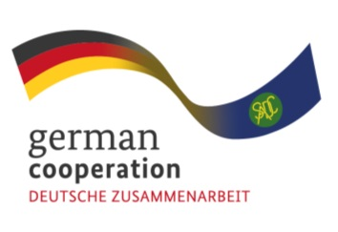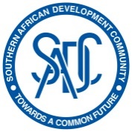

**Invitation to tender Advert (83433923)**

**Consultancy advert for the Joint Action SIPS to provide oversight and advisory services during the development and implementation of the SADC regional industrial pharmacy fellowship**

The Southern African Development Community (SADC) Secretariat, the European Union (EU) and the German Federal Ministry for Economic Cooperation and Development (BMZ) are jointly supporting the “COVID-19-relevant Medical and Pharmaceutical Products” (CMPP), the Antiretroviral (ARV) and Leather regional value-chain (RVC) projects. These RVCs are part of the Joint Action “Support towards Industrialization and the Productive Sectors in the SADC region (SIPS) project. The Joint Action aims to enhance business, entrepreneurial and subject matter knowledge skills by facilitating the development of industry knowledge clusters between the private sector and academic / training institutions within the antiretroviral (ARV) value chain.

To achieve this output, the Joint Action SIPS is supporting the development of a SADC Regional Industrial Pharmacy Fellowship to increase the availability of skilled industrial pharmaceutical personnel in the SADC region.

The scope of this assignment is to provide oversight and advisory services during the development and implementation of the SADC Regional Industrial Pharmacy Fellowship.

It is against this backdrop, that The Joint Action SIPS invites competent and qualified companies with experts in curriculum development based in Africa continent for this assignment. (Continent of Africa tender).

**Submission deadline**

Kindly submit your bid, comprising (i) a technical offer and (ii) price offer by 2 May 2023, 15.00hrs by email submission to BW_Quotation@giz.de. Please note that tender bids received after the stipulated time, date will not be accepted.