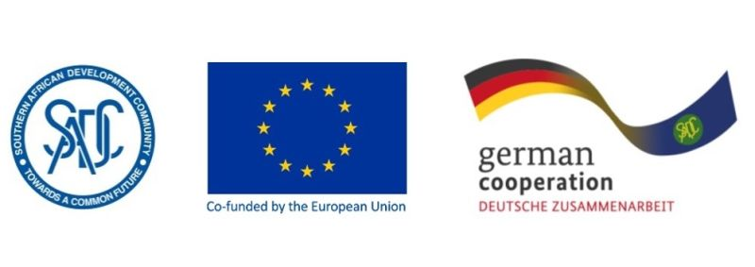

**RE-TENDER Contract 83432068**

**Invitation advert**: RSAP V Resource Mobilisation Plan

The *Deutsche Gesellschaft für Internationale Zusammenarbeit* (GIZ) supports the SADC Secretariat Water Division in the coordination of the Regional Strategic Action Plan on Water Resources Management and Development, 2021-2025 (RSAP V). RSAP V provides a common framework and shared philosophy for all stakeholders in the SADC water sector to contribute towards the SADC vision. The RSAP V is costed at approximately 100 million Euros. The subsequent task is now to identify current funding investments and to mobilise potential additional financial resources and quantifiable in-kind contributions for the implementation of RSAP V activities.

It is against this background that GIZ is seeking the services of an individual consultant in strategy and resource mobilisation. The objective of the assignment is to support the SADC water sector, including its stakeholders (i.e., SADC Secretariat, SADC implementing agencies, River Basin Organisations - RBOs, International Cooperating Partners - ICPs) in effectively identifying existing and mobilising additional financial resources for activities in the RSAP V. To this end, a mapping of potential funding sources will be conducted, and a resource mobilisation plan will be developed.

**Submission deadline**

Kindly submit your bid no later than 10th April 2023, 1700hrs, to [BW_Quotation@giz.de](mailto:BW_Quotation@giz.de) comprising of (i) technical offer and (ii) price offer. Please note that tender bids received after the stipulated time, date will not be accepted.

**Please note that this is a regional tender for SADC region-based individual Consultants ONLY.**