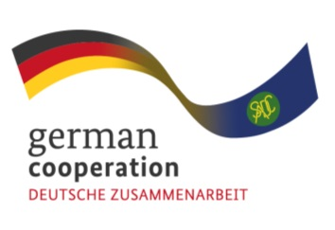

CALL FOR EXPRESSION OF INTEREST
Medical and Pharmaceutical Value Chain in the SADC Region
The Southern African Development Community (SADC) Secretariat, the European Union (EU) and the German Federal Ministry for Economic Cooperation and Development (BMZ) are jointly supporting the “COVID-19-relevant Medical and Pharmaceutical Products” (CMPP), the Antiretroviral (ARV) and Leather regional value-chain (RVC) projects. These RVCs are part of the Joint Action “Support towards Industrialization and the Productive Sectors in the SADC region (SIPS) project.

Improving knowledge, systems, and procedures in the management of businesses is a key aspect of the intervention activities under the Joint Action SIPS. In this respect, product certification is one of the focus areas to ensure that the CMPP VC companies manufacture high-quality-assured medical and pharmaceutical products in full compliance to national, regional and/or international regulations and standards. The Joint Action SIPS aims to provide technical assistance to selected CMPP VC companies in the SADC region to strengthen the capacity of private sector companies for regulatory certification readiness. The objective of this assignment is to:
- Facilitate a regulatory requirements workshop for the CMPP
- Conduct in-depth assessments of the selected CMPP companies’ current product certification readiness status, relative to relevant regulatory/QMS requirements and identify needs/gaps
- Develop time-bound action-plans to address identified product certification readiness gaps/needs at the companies
Eligible bidders must demonstrate the following:
- Average annual turnover of EUR20,000.00 over the last 3 financial years
- Average of 3 employees and managers over the last 3 calendar years
- At least 2 reference projects on Medical products certification/approval
- At least 2 reference projects on Quality Management Systems (e.g. ISO 13485)
- Demonstrable technical experience in the following areas: Medical Products Certification/Approval; Regulatory Frameworks particularly for Medical Devices; Quality Management Systems (QMS) e.g. ISO 13485; Product Master File development
- SADC regional experience
The Joint Action SIPS is therefore inviting interested service providers from the SADC region to submit an expression of interest for the assignment.
Interested parties wishing to participate in this preliminary selection to submit their documents as above (1-6), subject matter: “Call for Expression of Interest, Ref Medical and Pharmaceutical Value Chain No. 83434981” to: BW_Quotation@giz.de latest by 13th April 2023 at 15:00hrs local time.

Note: enquiries received after the above stated deadline date and time will not be considered: responses will only be shared after closing date.

