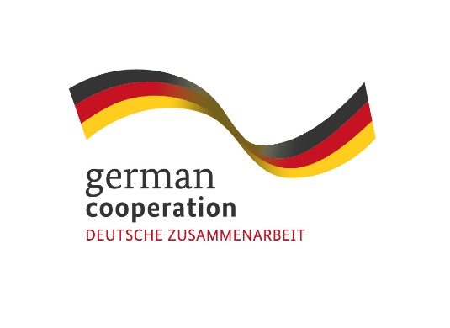
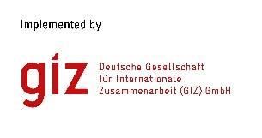
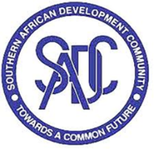

Contract 83431550

Invitation to tender advert: Assessment of SADC's "Disaster risk coordination mechanism"

The Deutsche Gesellschaft für Internationale Zusammenarbeit (GIZ) GmbH supports the Southern African Development Community (SADC) Secretariat’s Disaster Risk Reduction (DRR) Unit through the SADC/GIZ Project “Global Initiative on Disaster Risk Management (GIDRM)” funded by the German Ministry of Economic Development and Cooperation (BMZ). The objective of GIDRM is to build capacities and skills of selected decision-makers and regional organizations and initiatives in Southern Africa and other global regions to enable the use of risk-informed development (RID) principles while taking account of context-specific fragility factors. To address the complex nature of risks and safeguard sustainable development, the GIZ through its Global Initiative on Disaster Risk Management (GIDRM), aims at strengthening risk governance and risk-informed development (RID) in the region.
GIDRM in cooperation with the SADC Secretariats Disaster Risk Reduction Unit (DRR) are looking for an individual consultant to assess the level of inclusion of Gender and RID in the SADC “Disaster Risk Coordination Mechanism” and develop concrete recommendations for mainstreaming RID and gender equity principles into its regional instruments and decision-making processes.
Submission deadline
Kindly submit your bid by email to BW_Quotation@giz.de no later than 9th March 2023, 1700 hrs. comprising of (i) a technical offer and (ii) price offer. Please note that tender bids received after the stipulated time, date will not be accepted.

Please note that this is a regional tender for SADC region-based individuals only.

