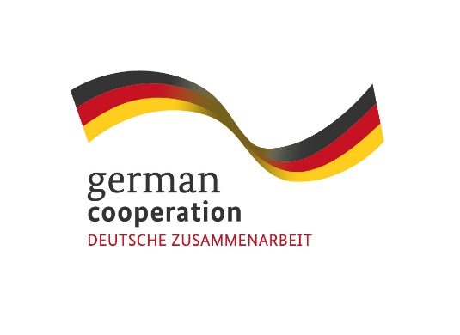
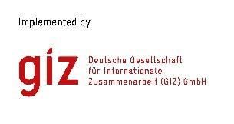
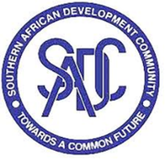

Contract 83431504

Invitation to tender
Advert: Development of Standardized Disaster Risk Management Assessment Tools

The Deutsche Gesellschaft für Internationale Zusammenarbeit (GIZ) GmbH supports the Southern African Development Community (SADC) Secretariat’s Disaster Risk Reduction (DRR) Unit through the SADC/GIZ Project “Global Initiative on Disaster Risk Management (GIDRM)” funded by the German Ministry of Economic Development and Cooperation (BMZ). The objective of GIDRM is to build capacities and skills of selected decision-makers and regional organizations and initiatives in Southern Africa and other global regions to enable the use of risk-informed development (RID) principles while taking account of context-specific fragility factors. To address the complex nature of risks and safeguard sustainable development, the GIZ through its Global Initiative on Disaster Risk Management (GIDRM), aims at strengthening risk governance and risk-informed development (RID) in the region.
GIDRM in collaboration with the SADC Secretariat’s Disaster Risk Reduction Unit (DRR) are looking for a qualified and competent company to develop Standardized Disaster Risk Management Assessment Tools (SDRMAT) to guide SADC Member States focusing on DRM situational assessment as well as rapid impact assessment to ensure timely and responsive actions in the face of disaster occurrences.

Submission deadline
Kindly submit your bid by email to BW_Quotation@giz.de no later than 16th March 2023, 1700 hrs. comprising of (i) a technical offer and (ii) price offer. Please note that tender bids received after the stipulated date and time will not be accepted.

Please note that this is a regional tender for SADC region-based companies only.

