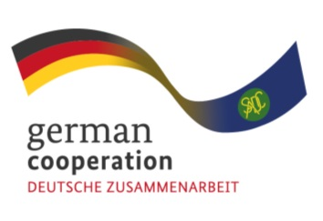
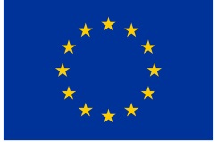

CONSULTANCY ADVERT FOR THE JOINT ACTION SIPS ENVIRONMENTAL SAFEGUARDS ASSESSMENT (contract 83431246)
The Southern African Development Community (SADC) Secretariat, the European Union (EU) and the German Federal Ministry for Economic Cooperation and Development (BMZ) are jointly supporting the “COVID-19-relevant Medical and Pharmaceutical Products” (CMPP), the Antiretroviral (ARV) and Leather regional value-chain (RVC) projects. These RVCs are part of the Joint Action “Support towards Industrialization and the Productive Sectors in the SADC region (SIPS) project.

The Joint Action SIPS aims to enhance knowledge, systems and procedures in the management of businesses across the RVCs, particularly the enhancement of environmental sustainability and ensuring their production systems are environmentally sustainable as per international and national environmental standards between relevant companies in the region. An important focus of the action is to ensure that the companies interact responsibly with the environment to avoid depletion or degradation of the resources. The objective of this assignment is to:
- Conduct an environmental awareness/sensitization workshop to enhance environmental management awareness among the representatives of the SIPS supported companies.
- Describe the national environmental regulatory framework/standards regarding the ARV and CMPP manufacturing sectors in the member states where the selected companies are operating;
- Conduct an on-site assessment of the environmental safeguards practices and identify compliance gaps with national environmental regulatory standards for each selected company;
- Prepare an action plan to address the identified compliance gaps and to enhance the antiretroviral and CMPP production systems and processes for environmental sustainability;
- Monitor the implementation of the action plan at a specified timepoint.
The Joint Action SIPS is therefore inviting qualified, competent and interested Service providers based in the SADC Region to apply for the assignment.

Submission deadline
Kindly submit your bid, comprising (i) a technical offer and (ii) price offer no later than 15th March 2023, 17.00hrs by email submission at BW_Quotation@giz.de. Please note that tender bids received after the stipulated time, date will not be accepted.

