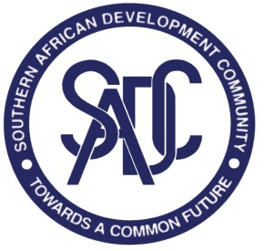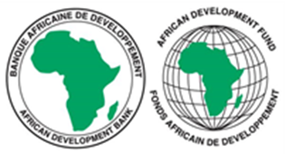

SOUTHERN AFRICAN DEVELOPMENT COMMUNITY (SADC) SECRETARIAT

REQUEST FOR EXPRESSIONS OF INTEREST (REOI)
(CONSULTING SERVICES- FIRM SELECTION)

PROJECT NAME: MACROECONOMIC STABILITY AND FINANCIAL INTERGRATION PROJECT IN THE SADC REGION

FINANCING AGREEMENT REFERENCE: 2100155041084

PROJECT ID NO.: P-Z1-KF0-067

DATE: 7 DECEMBER 2022

The Southern African Development Community (SADC) Secretariat has received financing from the African Development Bank toward the cost of the MACROECONOMIC STABILITY AND FINANCIAL INTERGRATION PROJECT IN THE SADC REGION and intends to apply part of the agreed amount for this grant to payments under the contract for CONSULTANCY TO PROVIDE AUDIT SERVICES FOR THE MACROECONOMIC STABILITY AND FINANCIAL INTEGRATION (MSFI) PROJECT IN SADC REGION.

The MSFI project objective is to enhance macroeconomic stability and convergence in the SADC region and to support the development of integrated of financial markets in SADC, to facilitate the most efficient allocation of savings and investment.

The overall objective of this consultancy assignment is to to review financial statements and to:
- To obtain reasonable assurance as to whether the financial statements as a whole are free from material misstatement, whether due to fraud or error. The conduct of an audit allows the auditor to express an opinion on whether the financial statements are prepared in all material respects, in accordance with an applicable financial reporting framework.
- Form a conclusion, report on the financial statements as a whole, and communicate as required;
- Obtain limited assurance whether the project books of accounts provide the basis for preparation of the PFSs by the Implementing Agency and are established to reflect the financial transactions in respect of the project. The Implementing Agency maintains adequate internal controls and supporting documentation for transactions.

The SADC Secretariat now invites eligible consulting firms to indicate their interest in providing these services. Interested consulting firms must provide information indicating that they are qualified to perform the services (i.e. description of similar assignments, experience in similar conditions and availability of appropriate skills among staff). The consulting firm should be registered and have a license from a national or regional professional Accountancy Body. The consulting firm should have relevant experience in accounting and auditing of development project/programs, especially donor-funded operations.

Consultants may constitute joint-ventures to enhance their chances of qualification.

Establishment of the short-list and the selection procedure shall be in accordance with the African Development Bank’s Procurement Policy for the Bank Group-funded Operations”, dated October 2015, which is available on the Bank’s website at http://www.afdb.org

Interested consultants may obtain further information at the address below during office hours 08h00hours to 16h30hours Botswana time.

Expressions of interest must be submitted electronically in PDF format and dully signed via this LINK: https://collab.sadc.int/s/3oQGHrRwBQXZ3s7 by midnight Botswana time on 9th January 2023 and should mention the name of the consultancy assignment. Bidders are advised to submit their proposals during working hours for support in case of any technical problems. The technical support team will not be available after working hours.

Below is the address for obtaining further information:

Attention: Acting Senior Procurement Officer
Mr Thomas Chabwera
SADC Secretariat
Plot 54385, New CBD
Private Bag 0095
Gaborone, Botswana

Tel: +267 395 1863

E-mail: tchabwera@sadc.int Copy: tnyamukondiwa@sadc.int; sdlamini@sadc.int; madams@sadc.int; mchiteba@sadc.int and tenders@sadc.int

