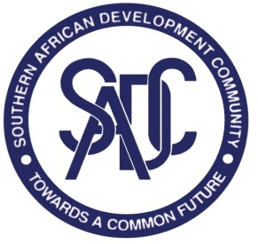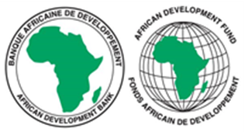

SOUTHERN AFRICAN DEVELOPMENT COMMUNITY (SADC) SECRETARIAT

REQUEST FOR EXPRESSIONS OF INTEREST (REOI)
(CONSULTING SERVICES- FIRM SELECTION)

READVERTISEMENT (EXTENSION OF SUBMISSION DATE ONLY)

PROJECT NAME: MACROECONOMIC STABILITY AND FINANCIAL INTERGRATION PROJECT IN THE SADC REGION

FINANCING AGREEMENT REFERENCE: 2100155041084

PROJECT ID NO.: P-Z1-KF0-067

DATE: 13 DECEMBER 2022

- The Southern African Development Community (SADC) Secretariat has received financing from the African Development Fund towards the cost of the MACROECONOMIC STABILITY AND FINANCIAL INTERGRATION PROJECT IN THE SADC REGION and intends to apply part of the agreed amount for this grant to payments under the contract for CONSULTANCY TO REVIEW MACROECONOMIC STATISTICS AND DEVELOP A WORKPLAN TO ADDRESS IDENTIFIED GAPS, HARMONIZE AND OPERATIONALISE THE REGIONAL DATABASE.

- The Macroeconomic Stability and Financial Integration project objective is to enhance macroeconomic stability and convergence in the SADC region and to support the development of integrated of financial markets in SADC, to facilitate the most efficient allocation of savings and investment.

- The overall objective of this consultancy assignment is to develop and operationalise a comprehensive and robust SADC Database comprising of harmonized and standardised Macroeconomic statistics for macroeconomic surveillance under the Macroeconomic Convergence Program.

- This assignment seeks to identify macroeconomic statistics gaps, come up with a workplan to address statistical gaps and harmonize and operationalise the macroeconomic database for macroeconomic surveillance. This assignment is expected to enhance the quality, quantity, accessibility, and timeliness of macroeconomic statistics, which are a critical enabler for macroeconomic convergence and stability in the SADC region.

- The SADC Secretariat now invites eligible consulting firms to indicate their interest in providing these services. Interested consulting firms must provide information indicating that they are qualified to perform the services (i.e. description of similar assignments, experience in similar conditions and availability of appropriate skills among staff).

- The consulting firm should have significant in-depth expertise and knowledge of IMF macroeconomic statistics manuals (government financial statistics, balance of payments, monetary statistics and national accounts); and significant in-depth international expertise and knowledge in economics and regional integration. The skills among the staff should include Team Leader, with general knowledge and experience in key areas of Economic Research, Policy and Statistics; Monetary Statistician with knowledge and experience in Monetary Statistics; Government Financial Statistician with general knowledge and experience in key areas of Public Finance; External Sector with general knowledge and experience in Balance of Payments; National Accounts with general knowledge and experience in National Accounts; and Database Expert with general knowledge and experience in Statistical Database design and maintenance.

- Consultants may constitute joint-ventures to enhance their chances of qualification.

- Establishment of the short-list and the selection procedure shall be in accordance with the African Development Bank’s Procurement Policy for the Bank Group-funded Operations”, dated October 2015, which is available on the Bank’s website at http://www.afdb.org

- Interested consultants may obtain further information at the address below during office hours 08h00hours to 16h30hours Botswana time.

- Expressions of interest must be submitted electronically in PDF format and dully signed via this LINK: https://collab.sadc.int/s/mgEE8LcBQ9cty6w by midnight Botswana time on 9th January 2023 and should mention the name of the consultancy assignment. Bidders are advised to submit their proposals during working hours for support in case of any technical problems. The technical support team will not be available after working hours.

- Below is the address for obtaining further information:

Attention: Acting Senior Procurement Officer
Mr Thomas Chabwera
SADC Secretariat
Plot 54385, New CBD
Private Bag 0095
Gaborone, Botswana

Tel: +267 395 1863

Email: tnyamukondiwa@sadc.int Copy tchabwera@sadc.int; sdlamini@sadc.int; hthomas@sadc.int and madams@sadc.int

