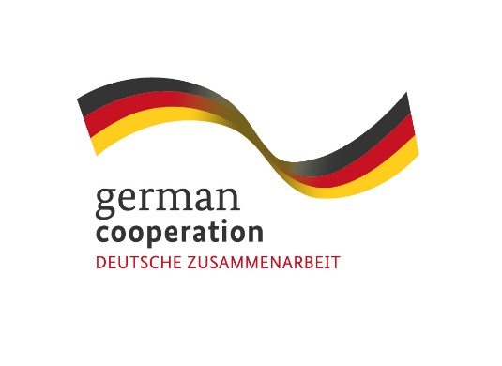
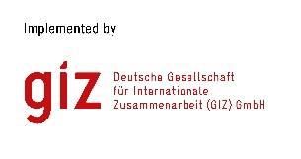
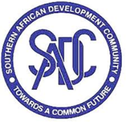
iz

Contract 83424222

Invitation to tender advert: Advice to Learning Energy Efficiency Network in the Tourism Sector

The German International Cooperation (GIZ) supports the SADC tourism sector in the implementation of energy efficient technologies. Against this background, the SADC/GIZ Climate Resilience and Natural Resource Management (C-NRM) project will promote a pilot Learning Energy Efficiency Network (LEEN) consisting of around 15 tourism enterprises in Botswana and Namibia located in the Kavango-Zambezi Transfrontier Conservation Area (KAZA). These enterprises with expressed interest in energy saving investments will be members of the network. The network will be managed by a moderator who will organise network meetings for exchange and learning. A consultant engineer will contribute with the technical advice and guidance for the enterprises.
C-NRM Project is inviting interested and qualified energy efficiency Consultant Engineers residing in Botswana, to carry out energy audits in the enterprises and analyze options for energy savings through more energy-efficient and/or renewable technologies resulting in economic savings and increased environmental performance of the enterprises.

Submission deadline
Kindly submit your bid no later than 28th November 2022, 17.00hrs to BW_Quotation@giz.de, comprising of (i) a technical offer and (ii) price offer. Please note that tender bids received after the stipulated time and date will not be accepted.

Please note that this is a tender for an individual consultant based in Botswana.

