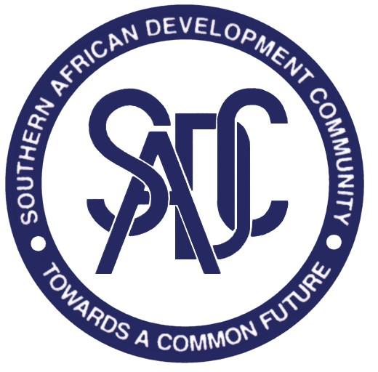

LAUNCH OF 2023 SADC MEDIA AWARDS COMPETITION

The Southern African Development Community (SADC) was founded as the Southern African Development Coordination Conference (SADCC) in 1980.

It was transformed into the Southern African Development Community (SADC) on 17th August, 1992 and consists of 16 Member States, namely; Angola, Botswana, Democratic Republic of Congo, Comoros, Eswatini, Lesotho, Madagascar, Malawi, Mauritius, Mozambique, Namibia, Seychelles, South Africa, United Republic of Tanzania, Zambia and Zimbabwe.

The SADC vision is one of a common future, within a regional community that will ensure economic well-being, improvement of the standard of living and quality of life, freedom and social justice, peace and security for the peoples of Southern Africa. This shared vision is anchored on common values and principles and the historical and cultural affinities that exist amongst the peoples of Southern Africa.

In 1995 the SADC Council of Ministers approved the establishment of the SADC Media Awards to recognise best media work in the region. Since 1996 the SADC Secretariat has been coordinating the Media Awards to encourage the media in the Region to play a leading role in disseminating information on SADC in order to support the process of regional co-operation and integration.

The SADC Secretariat now is pleased to announce the 2023 SADC Media Awards Competition. The Awards are in the fields of Print Journalism, Radio Journalism, Television Journalism and Photo journalism. Prospective entrants are invited to submit their entries accompanied by proof of their nationality to the National Adjudication Committee (NAC) in their respective Member States.

Rules of the competition

- The entries should have been published/broadcast between January and December the year preceding the awards (2022) by a registered and/or authorized media house or agency or carried on a website of a registered and/or authorized media house or agency in any of the SADC Member States;

- The themes of the entries to be submitted for the competition must be on issues and activities promoting Regional Integration in the SADC region, i.e. infrastructure, economy, water, culture, sports, agriculture, etc.

- All media practitioners who are SADC nationals may enter the competition, except those in institutions contracted by SADC and the SADC Secretariat staff;

- All works entering the competition should be in one of the SADC working languages, i.e. English, Portuguese, French and any national indigenous language of the SADC Region and should be submitted together with the transcript in one of the three SADC working languages, i.e. English, French and Portuguese. These should be published/broadcast (newspaper cutting, websites, magazines, audio CDs, USB and newsletters;

- Entries are invited from the following categories:

- Print Journalism: comprising features/articles published in newspapers, newsletters, websites, magazines;

• Print Journalism submissions should have a minimum of 100 (one hundred words and a maximum of 2000 (two thousand) words.

- Radio Journalism: comprising broadcast material;

• Radio Journalism broadcast material should have a minimum duration of 1 (one) minute and a maximum of 30 (thirty) minutes. All broadcast material should be submitted on a CD or USB. The entries should be accompanied by electronic transcript in word format for translation purposes.

iii)Television Journalism: comprising televised material;

• Broadcast material should have a minimum duration of 1 (one) minute and a maximum of forty-five (45) minutes. All broadcast material should be submitted on a CD or USB. The entries should be accompanied by electronic transcript in word format for translation purposes.

iv) Photojournalism: comprising published pictures with a caption;

• Photographic entries should have one (1) photo, or a pictorial spread of not more than twenty (20) photos published in one issue/edition. Each entry must be accompanied by an original newspaper in which photo (s) were published.

f) All entries must be submitted to the National Adjudication Committee not later than February 28, 2023.

g) All submissions must be made strictly on the SADC Media Award Entry Form and should contain full contact details of the entrant, including, passport-sized photograph, physical address, telephone and, where applicable, fax number and e-mail address;

h) Entries will be initially screened and judged by the National Adjudication Committee in each Member State, which will select the best entry in each of the four categories to be forwarded to the Regional Adjudication Committee (RAC), through the SADC Secretariat.

i) Selection of the best regional entries will be decided upon by the RAC;

j) The decision of the RAC shall be final;

k) The first prize winners will be announced and receive their prizes during the 39th SADC Summit of Heads of State and Government;

l) The Awards will include Print, Radio, Television and Photo journalism. Each category carries a first prize of US$2,500;

m) The runner-ups in each category will receive a second prize of US$1000 and will receive the prize money and certificates in their respective countries through their National Contact Point;

n) The monetary prizes will be accompanied by a certificate signed by the SADC Chairperson;

o) The prizes will be paid directly to the winner. In the case of a winner being unable to attend the ceremony, SADC will make arrangements to give the prize in his/her home country;

p) The RAC reserves the right not to award a prize in any of the categories if the entries do not satisfactorily meet the competition requirements.

Further information and entry forms are obtainable from the National Adjudication Committees, SADC Media Coordinators (NMCs) in each Member State and SADC Website (www.sadc.int) .

The list of NMCs can be found on https://www.sadc.int/media-centre/media-contacts

