|  |  |
| --- | --- |
| **Project Title: Support in Industrialization and Productive Sectors (SIPS) in the SADC region**  **Country: Southern Africa Development Community, SADC (Botswana)**  **Improving Private Sector Participation in the Leather Value Chain in the SADC Region.**  **Consultancy services for Pilot Country Project 2 “Harnessing of Hides and Skins for leather products in Namibia”** | **Project number/ cost centre:17.2034.1-010.00** |

0. List of abbreviations 2

1. Context 3

2. Tasks to be performed by the contractor 11

3. Concept 18

(a) Technical-methodological concept 19

4. Personnel concept 22

5. Costing requirements 24

Assignment of personnel 24

Assignment of personnel **Error! Bookmark not defined.**

Travel 24

Workshops, training 24

Other costs 24

Flexible remuneration item 24

6. Requirements on the format of the bid 25

7. Option

# List of abbreviations

AVB GIZ General Terms and Conditions of Contract (AVB) for supplying services and work 2020

ARV Antiretroviral

BMZ Federal Ministry of economic cooperation and development

CMPP Covid19 relevant medical and pharmaceutical products

CO2 Carbon dioxide

EDF European Development Fund

EU European Union

GIZ Deutsche Gesellschaft für Internationale Zusammenarbeit GmbH

LVC Leather Value Chain

MOU Memorandum of understanding

MOA Memorandum of agreement

M&E Monitoring and Evaluation

NCA Northern Communal Areas

NNFU Namibia National Farmers Union

OHS Occupational Health and Safety

PTSC Project Technical Steering Committee

RVC Regional Value Chains

SADC Southern African Development Community

SIPS Support towards Industrialization and Productive Sectors in the SADC region

SME Small and Medium sized Enterprises

ToR Terms of reference

VC Value Chain

VCF Veterinary Cordon Fence

# Context

**Introduction**

The Joint Action “Support towards Industrialisation and the Productive Sectors (SIPS)” in the SADC region is supported by the European Union (EU) under theEuropean Development Fund (EDF) 11 as approved by the European Commission in October 2018.The overall objective of the SIPS Programme is to contribute to the Southern African Development Community (SADC) industrialisation and regional integration agenda. The project purpose (specific objective) is to improve the performance and growth of selected regional value chains and related services within the leather, pharmaceutical and medical products sectors.

The Joint Action SIPS addresses key concerns of the private sector that are currently impeding industrialisation in the SADC region, by addressing both market coordination and linkage failures between the national and regional level as well as between the public and private sector. To implement the overall SIPS Programme, the EU concluded a financing agreement with SADC, referred to in Article 17 of Annex IV to the ACP-EU Partnership Agreement. SADC Secretariat coordinates the overall Programme and is responsible for implementing Result 1 dealing with policy and regulatory related issues of strengthening regional value chains (RVC).

The EU and the SADC Secretariat have identified the Deutsche Gesellschaft für Internationale Zusammenarbeit (GIZ) GmbH as the lead implementing agency for the Results 2 and 3 of the SIPS Programme (in the framework of a co-financed Contribution Agreement). GIZ is implementing the Private Sector Component through a Multi-donor Action (the Joint Action SIPS hereafter) that is jointly co-financed by the European Union and the Federal Republic of Germany’s Federal Ministry for Economic Cooperation and Development (BMZ). GIZ implements the Private Sector Component of SIPS as part of the BMZ-commissioned programme “Cooperation for the Enhancement of Southern African Development Community (SADC) Regional Economic Integration” (CESARE II). The Multi-Donor Action has an implementation period of up to 41 months, expected to commence on 01 October 2019, and a total financial volume of 12,830,000 EUR.

* 1. Objectives and Results

The Joint Action SIPS is based on the pre-defined objectives and results outlined in the Action Document of the 11th EDF Programme for Component 2: Private Sector Development (Result Area 2 and 3) of the SIPS Programme, complemented by result 2.2 in 2020 to support the SADC region in mitigating the impact of the world-wide Covid-19 crisis in an enduring way. Together with Component 1: Enhanced Policy and regulatory Framework, the overall objective of the SIPS Programme is to contribute to the SADC industrialisation and regional integration agenda.

According to the Action Document and including the Covid-19-response, the expected Results (Output) of Component 2 are:

Result 2: Private sector participation in regional leather, pharmaceutical and medical value chains enhanced.

Result 2.1: Private sector participation in the regional anti-retroviral (ARV) value chain enhanced.

Result 2.2: Private sector participation in the regional Covid-19-relevant medical and pharmaceutical products (CMPP) value chains enhanced.

Result 3: Private sector participation in regional leather value chain enhanced.

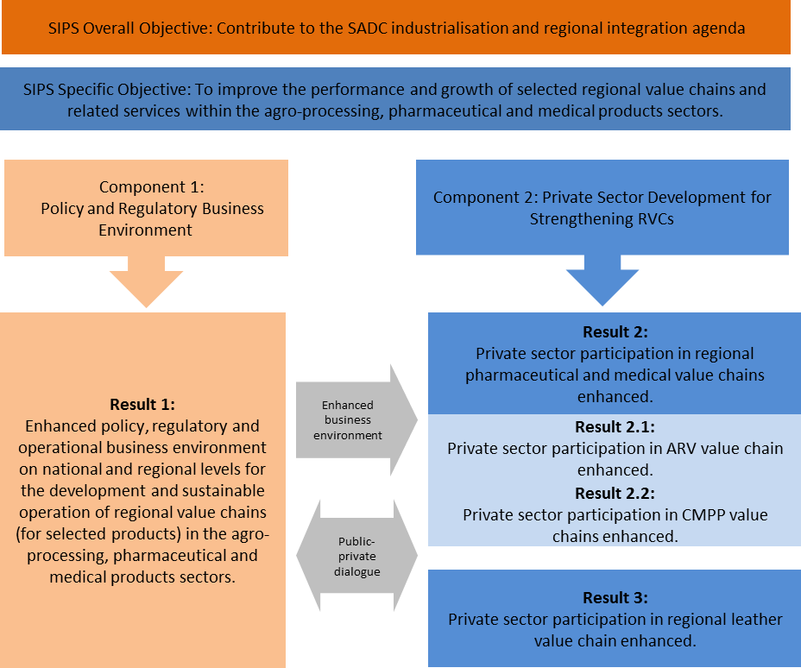

SADC, while implementing Component 1, is responsible for all interaction with Member State governments and for the policy and regulatory framework condition. GIZ, while implementing Component 2, is responsible for the interaction with the private sector from selected Member States.

Unless explicitly stated otherwise, this tender and the terms “the Action” or “this Action” in this Annex refer to the Multi-donor Action for the implementation of the Private Sector Component (Component 2, Result 3) of SIPS that is being implemented by GIZ which refers to enhancing the Leather Value Chain in the SADC region. Component 1 (Result 1) has its own separate implementation arrangement. GIZ seeks to make all efforts to ensure that the two SIPS Components are implemented in a coordinated way and complement each other.

* 1. Economic potential and constraints of the Leather value chain

The agricultural sector is of major social and economic importance in the SADC region, and contributes between 4% and 27 % to the GDP, across different Member States and approximately 13% of overall export earnings. This sector is dominated by smallholder traditional farming systems and a relatively high percentage of livestock population in the SADC region estimated at about 75%. The collection ratio of hides and skins is estimated to be below 50% in many SADC Member States because slaughter is not controlled or centralized, and the quality of the skins is often low. SADC Member States are part of the global leather value chain, however their earnings from these activities are undermined by point of entry into the value chain. Admittedly, the production of raw hides and skins has increased and consequently the employment levels. However, profits have not shown the same trend. All stages of the SADC leather value chains have significant deficits compared to leading international leather manufacturing countries, for example, Italy, China and Brazil among others. Reasons for the inadequate and often challenged positions are the quality of the incoming hides and skins into the processing industries, resulting in limited product output. Additional constraints that have been identified, include supply service, lack of market access, low production efficiency, energy fluctuations, outdated technology systems, production equipment, processing skills, on time delivery and coordination within the broader scope of the sector, resulting in limited growth due to the above challenges.

A regional leather value chain operates across borders to export raw material (hides and skins, wet blue and crust) and imports of finished goods exists in the SADC region. There are several intra-regional business interactions taking place within the region both formal and informal. For example: Small and medium enterprises (SMEs) in Malawi source finished leather, soles and other accessories from Zambia and Zimbabwe; SMEs in Zimbabwe source high quality leather and off-cuts from the automotive industry and other required accessories from South Africa; South African enterprises export footwear for safety, security and school shoe sector to several SADC countries; Botswana and Zimbabwe export raw hides and skins to South Africa; Zimbabwe exports military and police footwear to varies SADC countries. The trade of raw materials hides and skins (to process into leather) or finished leather (production of leather goods) is often a double arrow flow between the countries that are importing e.g., raw material (hides in wet blue) but at the same time are exporting leather that will be used to produce finished leather goods. In comparison with global figures the trade of raw hides, skins, semi- processed leather and leather goods within SADC remains very limited.

The leather value chain within the SADC region faces increasing pressure regionally and internationally due to stricter regulations. Meeting these, linked to quality expectations, labour equity laws and OHS (occupational health & safety) standards are emerging as stricter marketing drivers and as additionally pre-requisite conditions to enter global brand and other leather product markets. Many tanneries in the region are not adequately equipped, thereby challenged to comply and fulfil the international high technical product standards. In addition, many international business opportunities require the compliance of social and environmental standards. SMEs in the sector are constrained by insufficient resources and thus lag in implementing these processes to meet the required standards. It is essential for enterprises to acquire and apply modern and greener technologies to improve product design and quality within the processing stages, enhancing competitiveness through resource optimisation. In the tanning sector, enterprises can enhance their competitiveness through the application of cleaner technologies such as chrome-free tanning, chrome recovery, use of vegetable and or synthetic tanning, improving production flow, reduction and recycling of water, alternative electricity generation and streamlining of industrial symbiotic systems. Traceability standards are further requirements, in the future supply of goods, as the trend of controllability and responsibility within the entire value chain, must show a reduction in CO2 emission levels, with the goal in carbon neutrality.

Some SADC Member States are implementing national leather development strategies focused to transform the value chain from the production and export of raw hides to the processing and export of finished or manufactured products. The basis of leather making is the input of raw hides and skins, which is a by-product from the meat processing industry. Unlike other commodities for example meat, cotton, sugar and grains, the leather value chain has received limited support from governments within the region. Prior to the economic structural adjustments programmes most of the commodities were coordinated by public funded institutions, for example meat commissions and cotton marketing boards just to mention a few. These structures were instrumental in developing commodity chains with central government funding, which was not the case with the Leather Value Chain (LVC) because of its by-product status, consequently the sector remained challenged and underdeveloped.

Few SADC Member States including South Africa, Tanzania, Zambia and Zimbabwe have production activities within every segment of the Leather VC, however outside South Africa most of the segments are underdeveloped. Tanzania, Zambia and Zimbabwe have instituted export restrictions on the export of raw hides and skins; however, these measures have not significantly assisted in the growth of the sector especially in Zambia and Zimbabwe. In the Zimbabwean case, the general unstable macroeconomic conditions over the past two decades have undermined all micro efforts to revive the value chain. This scenario maybe indicative of the fact that Value Chain (VC) development requires a holistic approach that places the private sector in the centre, with the government providing a facilitation role through the provision of demand driven services and other incentives. For example, the South African leather industry presented a downward trend in specific areas in the value chain, such as the shoe manufacturing sector within the economy in the mid-nineties. Now, the country is on the recovery path because of the industrial growth and competitiveness support schemes that were instituted by Government through the Department of Trade and Industry and Industrial Development Corporation.

Looking at the overall demand, the LVC has a substantial product range from footwear, garments and other leather goods. Footwear, however, is the most significant product as its traditional consumption is estimated to be between 50% and 60% of all leather produced globally. Therefore, footwear is used as a guideline of the overall demand for leather products globally. Currently the local market of finished leather goods is dominated through cheaper imports from China. The potential for local production and local/regional sales is high in view of demand and growing consumer numbers.

* 1. Inception Phase Activities: Leather Value Chain

As part of the inception phase, a detailed mapping and profiling analysis of the leather sector was conducted following the value chain approach. An assessment of each SADC Member State describes the respective performance in the different stages of the LVC as per the diagram below. Several regional experts conducted the assessments applying the value chain methodology. As a result, there are individual reports on all 16 SADC Member States, which have been condensed and included in the LVC inception report, outlining the various value chain activities to define through procurement efforts, processing of raw materials into leather, semi-processed product supply, finishing and manufacturing.

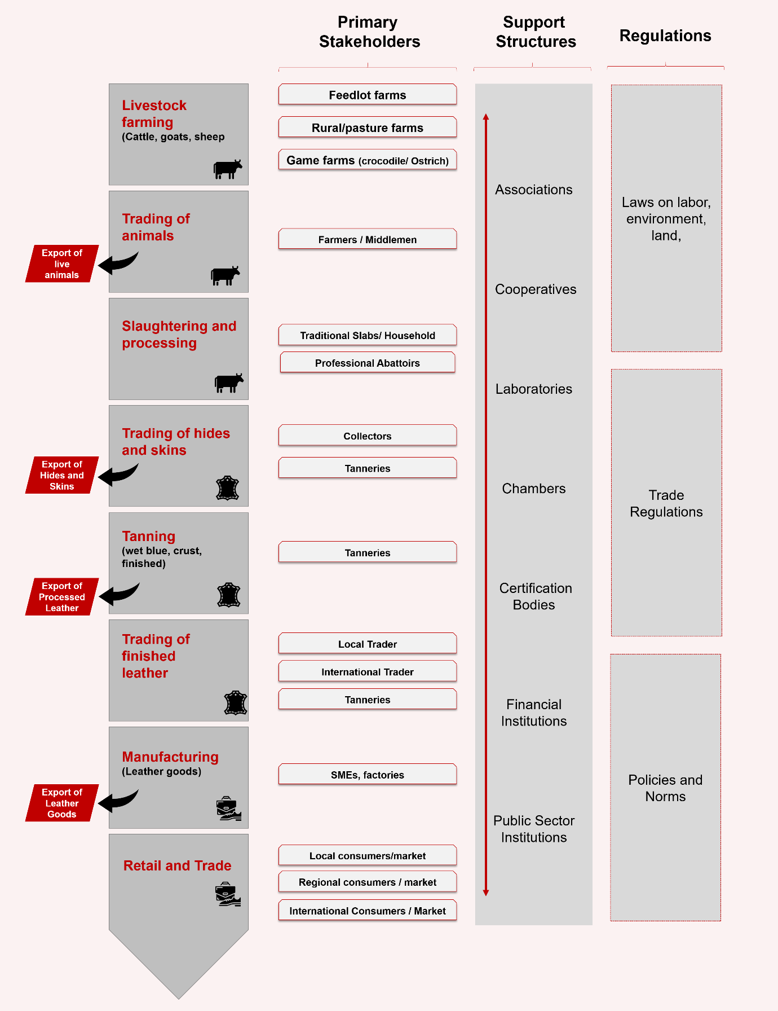

***Value chain mapping in SADC Member States***

The purpose of the LVC inception report was to analyse the economic potential and challenges of the industry within the SADC region. The study took into consideration the different processing methods and outcome in each stage identifying key state players. In addition, leather-related activities in the SADC region were compared to global performance indicators representing the market position of the Member States. It also provides a general insight into trade figures, business relations, price development, global market trends and technologies in the regional LVC. An outline is given as to the South African leather market as a key player in the region, to serve as a benchmark in the overall leather industry. Moreover, the report entails a brief presentation on relevant infrastructure, environmental framework conditions and existing support structures at government level. The study also covered cross-cutting issues on protection mechanisms, climate, security, gender equity, youth, HIV and Covid‑19 with the resulting impact on the Leather VC within the region. The study was concluded with a proposal, presenting strategic interventions to foster and grow the LVC in SADC.

1.3.1 Leather Inception Report Results and further Scoping

The estimated cattle stock in Namibia in the Northern Communal Areas (NCA) or North of the Veterinary Cordon Fence (VCF) was 1.1 million in 2017 and due to the severe drought declined to an estimated 500 000 in 2021. The breed quality of the cattle in the commercial farming in Namibia area is of high quality, which is found south of the VCF, however, live cattle (64%) and sheep (61.7%) is mainly exported to South African abattoirs and feedlots. The VCF is a pest execution fence, separating northern Namibia from the central and southern country parts. Currently in Namibia MeatCo is by far the biggest abattoir and commercial player in the Namibian Beef Industry. In addition, MeatCo owns Okapuka Tannery with feedlot operations approximately 80km from the capital city, Windhoek. Due to the ongoing exportation of live cattle to South Africa there is a decrease in the overall number of livestock slaughtered in Namibia.

It should however be noted that there is low quality of hides and skins in Namibia. The hides and skins are currently largely damaged through livestock branding and uncontrolled slaughtering methods, linked to a lack or limited veterinary control within the holding of livestock. Due to the environment in which the animals are kept, such as harsh bushland, may lead to skin damages resulting in lower quality of raw material for the leather industry. The local raw material price in Namibia is strongly influenced by the South African off-take.

* + 1. LVC: Pilot country methodology and strategy

The Leather Team, under the SIPS programme, tabled a strategy after analysing the inception report (concluded by external consultants). The strategy identified a needs-based pilot country approach in which SADC Member States are addressed according to their current development needs in the leather value chain. Thus, this approach intends to support local industries with already existing structures.

For some Members States, with no or limited value addition in this sector, a procurement and collection system for hides needs to be established to enable value addition beyond the slaughtering stage. Similarly, in some Member States, stages of the LVC may be limited or non-existent (e.g. tanneries); however, a cross border cooperative approach may be of higher importance, where available resources in one country may enhance the supply chain for the counterpart country for cooperative trade to increase.

South Africa will not be actively involved as a pilot country, however benchmarking the industry, for best practices and current structures in the leather value chain should be taken into consideration.

Governmental initiative structures play a major role for business operational activities; however, the deciding factors will be presented by customer interventions and standards, guiding the pilot country approach. The envisaged outcome consists of groups of companies that share local resources, use similar technologies, forming linkages, alliances and increasing their networks, resulting in joint training, marketing, or research initiatives. Group purchasing allows competitive buying of local and imported products. The companies remain competitors on a customer level, but synergies created should be beneficial for all. The approach can be also called “co-competitors”. The cooperative idea consists of creating an enabling environment for business in the leather sector on different stages of the value chain, to increase knowledge of the target groups and to create transnational synergies between value chain actors. Target groups within the pilot country approach are companies or other forms of business organisations like cooperatives on every level of the leather value chain. A close cooperation on a meso level with different business structures, like associations and non-governmental entities being active in the leather sector is essential for a successful implementation of the pilot approach.

In total **four projects** are identified: (All projects are independent from each other, however, may have linkages in the overall success of the LVC projects.)

**Project 1: Raw material supply and procurement strategy**

The objective of this intervention is to support the utilisation of non-commercial value hides and skins by stakeholders and generate additional income at the entry point of the value chain. Hides and skins should become a product that is to be regarded as valuable and not discarded. Identification of groups, associations and individuals is principal to structure a cooperative business engagement to ensure growth and market opportunities domestically and regionally.

**Project 2: Harnessing of hides and skins as a leather product** with the objective to reduce the damages to hides and skins, creating increased awareness of their value and resulting in potentially higher revenues. The designated country for pilot project 2 is Namibia.

**Project 3: Increasing market shares of existing underutilized tanneries** with the objective to increase the production capacity of existing tanneries, mitigating the risk of potential closure and creating incentives for new investments.

**Project 4: Manufacturing of leather goods** aims to increase market shares and turnover of current manufacturers alongside the creation of incentives for start-ups and potential investors.

**LVC Pilot country approach phase and roll-out phase**

The pilot project approach intends to have a spill-over effect to stakeholders of the LVC within SADC that face comparably similar situations and challenges in their respective value chain stages according to the Inception Report findings. SADC Member States neither have the same framework conditions nor the same level of development. The project approach only works if the pilot strategy is adapted to the beneficiaries needs and applied within target Member States with aligned interests. For the duration of this contract, the strategies should be implemented on a small-scale level per projects 1-4. The overall project approach remains, but is limited to one country, as per the project outline:

Pilot project 1: Angola

Pilot project 2: Namibia

Pilot project 3: Tanzania

Pilot project 4: Tanzania

The objective of the pilot country approach is to implement a successful strategy to foster the LVC at every project level, to evaluate the lessons learnt from this implementation and to develop a roll-out strategy for the second phase (“phase 2”). The roll out phase will be a separate contract (see below for further information).

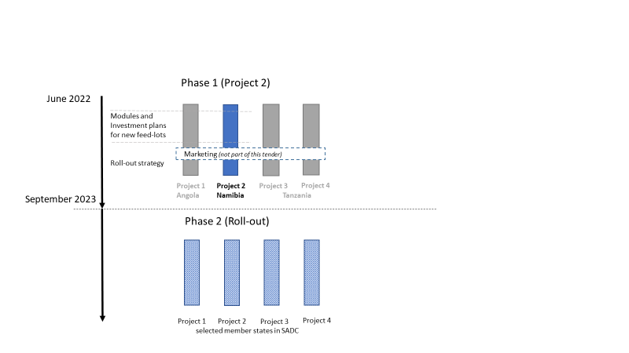

The pilot country project 2 will be implemented in Namibia starting after contract signing and ending in October 2023. Within this period, the activities should be concluded as per defined

The regional roll-out strategy (phase 2) will be contracted separately and is to be implemented in additional SADC Member States. The roll-out takes all findings and recommendations from the Project 2 contractor in the pilot phase into consideration, presenting a feasibility model, social impact and further benefits for the implementation of the next phase.

**The tasks of these Terms of Reference relate only to project 2**

**Project 2: Harnessing of Hides and Skins as leather products (Namibia)**

**Objective**: To reduce the damages to hides and skins by increasing awareness of their value and potential higher revenues. The significance of hide and skin quality improvement could have a leveraging effect on the processing tanneries. In addition, adopt a model that will allow for farmers to improve their daily operational management, planning and business decision evaluations.

**Strategy:**

The primary focus is to reduce damages to hides and skins. The tasks will be accomplished through the introduction and promotion of cooperative feedlot hotels to farmers. Trainings and workshops are to be done to ensure that farmers understand and participate in the value of hide and skin care in farms and feedlots. These trainings will be centred on good animal husbandry practices and ways on adopting a quality management systems (QMS) model in their individual farming operations.

Trainings and guidance in implementing a quality management systems model will allow farmers to adopt a systematic approach on documenting and improving their production practices, refining how they manage the day-to- day activities (daily operational management, planning and business evaluation decisions) in farming.

Target group(s):

* Livestock farmers;
* Cattle breeders; and
* Farmers (or related) Associations who may have access to existing feedlot operations
* Abattoirs
* Feedlot Operators
* Tanneries

# Tasks to be performed by the contractor

The contractor is responsible for providing the following services:

Assess the existence of feedlots in Namibia and the key actors, or propose a model if it is non-existent;

Create or enhance a feedlot integration concept with focus on assessment of costs to operate a feedlot hotel (procurement, logistics and management);

Organise and facilitate an introduction workshop with the key focus of introducing Pilot Country Project 2 to representative stakeholders.

Establish a cooperative for farmers to participate in feedlot usage in Namibia.

Organise and facilitate trainings on the following; QMS, feedlot management and husbandry practices.

Develop and implement a QMS model with farmers participating in the feedlot hotel.

1. Monitor and evaluate the project from inception 7 November 2022 to completion of project 31st October 2023.
2. Develop a roll-out strategy which will be used to facilitate implementation in the next project phase (not a part of this contract) by taking lessons gained from the Pilot Country 2 Project and propose future activities.

The total number of expert days for all experts (1 team lead and 2 short term experts) will equate to two hundred and ten (210).

The team leader is expected to perform the following tasks;

1. Oversee all activities of the project;
2. Select and prepare project tasks including training plan and steer the short-term experts assigned to perform the technical tasks;
3. Facilitate the participation of farmers in the feedlot hotel integration concept;
4. Manage costs and expenditures, accounting processes and invoicing in line with the requirements of GIZ;
5. Ensure timely implementation;
6. Develop a training manual for local farming communities on good animal husbandry practices and feedlot hotel management (with focus on business, environmental management, production quality improvement, green technology, resource efficient production)
7. Develop a manual for the training farmers on QMS and support the adoption of a model by farmers.
8. Assure the continuous communication with the GIZ LVC Team to inform about potential or actual discrepancies, planned missions and short-term experts deployed; activities like workshops and mission progress; and
9. Delivery of reports

The two to three short term experts are expected to perform the following tasks;

1. Support procurement logistics and management needs of farmers & stakeholders participating in the project (transportation of cattle, safety and security logistics, feed and healthcare product supply etc);
2. Calculate and present a cost assessment for the implementation of a feedlot hotel;
3. Operational implementation of proposed activities (see table 1);
4. Train local farming communities on good animal husbandry practices and feedlot hotel management (with focus on business, environmental management, production quality improvement, green technology, resource efficient production)
5. Train farmers on QMS and support the adoption of a model by farmers.

**Deadline and Deliverables**

The contractor will propose a methodology for implementation of the pilot country approach guided by the SIPS team to ensure the achievement of the defined results and milestones, aligned and supported by the SIPS team. In addition to the allocated responsibilities cited above, the following milestones are to be achieved within the defined timeframe:

**Tasks of the Team Leader**

|  |  |  |  |  |
| --- | --- | --- | --- | --- |
| **Tasks** | **Deliverables** | **Deadline** | **Distribution of working days** | **Distribution of travelling days**  **(Outward and return/ round trip)** |
| **Section A: Creation of Alliances** | | | | |
| Conduct an assessment of key players in the livestock industry. | One (1) assessment report of relevant key players in the livestock industry. | **2 months after contract signature** | 15 days | 1 regional travel day to Windhoek  2 travel days outside Windhoek |
| Organise and conduct a workshop with the focus of introducing Pilot Country Project 2 to relevant stakeholders. | One (1) Pilot Country Project 2 Introduction workshop  Workshop Report | **2 months after contract signature** | 4 days (2 days for preparation + 1 day for workshop + 1 day for the report) | None |
| * Support the creation of a cooperative structure for farmers to participate in the feedlot hotel concept. * Support the alliance of a formal agreement between   1. One (1) feedlot owner(s) and the cooperative   2. Farmers participating in the feedlot and tanneries | 1. One (1) Memorandum of Agreement for the establishment of a cooperative structure 2. One (1) Memorandum of Agreement amongst feedlot owners and farmers in the participation of a feedlot hotel | **3 months after contract signature** | 10 days (arranging virtual/physical meetings, preparing MOU documents etc.) | 3 travel days allocated outside Windhoek within approximately 500 kms |
| **Section B: End of project reports** (Home/Desk Based) | | | | |
| According to GIZ standards, produce a results-based monitoring and evaluation report according to the indicators (refer below) | 1. Monitoring and Evaluation completed. 2. Final report. | **11 months after start of contract** | 10 days | None |
| **Development of a roll-out strategy for project 2**  Develop a roll-out strategy and a report that will be used to facilitate implementation in the next project phase (not a part of this contract) by taking lessons gained from the Pilot Country 2 Project and propose future activities. | (One) roll-out strategy report highlighting roll out plan | **12 months after start of contract** | 5 days | None |
| **Total Number of Assignment days** |  |  | **44** |  |
| **Total Number of Travel days** |  |  |  | **6** |

**Tasks of the Short-Term Experts**

|  |  |  |  |  |  |
| --- | --- | --- | --- | --- | --- |
| **Tasks** | | **Deliverables** | **Deadline** | **Distribution of working days (for 2 experts)** | **Distribution of travelling days**  **(Outward and return/ round trip)** |
| **Section B: Logistics, procurement and management of Feedlot Hotel** | | | | | |
| Calculate and present a cost assessment for the implementation of a feedlot hotel with focus on procurement, logistics and management. This should look at some of the following key areas;   * transportation of cattle including permits and vaccinations; * safety; * security logistics; * feed; * environmental management and * healthcare product supply. | | One (1) cost assessment report | **3 months after contract signature** | 5 days (meetings with stakeholders, 2 days for drafting cost assessment report etc.) | 1 regional  travel day to Windhoek (per expert)  2 travel days outside Windhoek |
| Facilitate the involvement of relevant key stakeholders (public or private)’ to support the business enabling environment for investments in feedlots through;   1. Identify and lease feedlots or designated land at favourable terms and conditions to cooperatives | | * One (1) Feed-lot land or location * Report on feedlot hotel pilot | **4 months after contract signature** | 5 days | None |
| Oversee feedlot hotel activities and management commencing latest 6 months after start of contract (3-month slots) | | * Feedlot Hotel Piloted | **12 months after start of contract** | 21 days (5 days at beginning of each cycle, 2 days at end of cycle) | None |
| Support and guide in engagement with transport companies on a logistical infrastructure plan to simplify the movement of livestock to the feedlot hotel and processing facilities (abattoirs, tanneries etc.) | | One (1) logistical infrastructure plan | **6 months after contract signature** | 2 days | None |
| **Section B : Planning and Implementation of trainings and QMS model** | | | | | |
| Develop a training plan and manual for   1. Quality Management systems model in the cattle industry 2. Good animal husbandry practices (i.e. all the measures adopted at the farm, from procuring and rearing healthy animals, their welfare, to slaughter.) | | One (1) training plan including relevant modules on quality management systems and good animal husbandry practices | **6 months after contract signature** | 10 working days | None |
| Organize and train farmers participating in the feedlot on Quality Management Systems highlighting practices and guidelines on producing a quality product. | | 1. One (1) training on Quality Management Systems for Farmers participating in the feedlot hotel 2. Report | **6 months after contract signature** | 4 days (2 days for preparation + 1 day for workshop + 1 day for the report) | None |
| Organize and facilitate a train- the- trainers session for Namibia National Farmers Union (NNFU) members on Quality Management Systems in the livestock industry to introduce to farmers in Namibia not participating in the feedlot hotel | | 1. One (1) training to trainers on Quality Management Systems 2. Report | **6 months after contract signature** | 4 days (2 days for preparation + 1 day for workshop + 1 day for the report) | None |
| Pilot Quality Management Systems model with farmers participating in the feedlot hotel with focus on:   * daily operational management * planning * business evaluation decisions. | | QMS model report on strengths and challenges in the pilot stage | **11 months after contract signature** | 20 days | None |
| Organize and facilitate training workshops on best sustainable animal husbandry practices | | 1. One (1) workshop with a minimum of fifty (50) participants from representative stakeholders on good animal husbandry practices in the North of Namibia      1. Report        1. One (1) workshop with a minimum of fifty (50) participants from representative stakeholders on good animal husbandry practices in the South of Namibia 2. Report | **6 months after contract signature** | 4 days (2 days for preparation + 1 day for workshop + 1 day for the report)              4 days (2 days for preparation + 1 day for workshop + 1 day for the report) | 3travel days – domestic flight/drive                    None |
| Organize and facilitate training workshops on feedlot management with focus on business, innovative financing arrangements, environmental management, production quality improvement, green technology, resource efficient production | | 1. One (1) training with a minimum of fifty (50) participants from representative stakeholders on feedlot management 2. Report | **7 months after start of contract** | 4 days (2 days for preparation + 1 day for workshop + 1 day for the report) | 2 travel days |
| **Total Number of Assignment days** |  | |  | 166 |  |
| **Total Number of Travel days (per expert)** |  | |  |  | **8** |

The project is expected to start in 7 November 2022 and end on the 31st October 2023.

**Results Based Monitoring**

The contractor takes an active role in the results-based monitoring of the project. The contractor's responsibility in this role is twofold:

1. The contractor shall collect all relevant data from participants to analyse the positive intended change through the project activities at least twice. First, before implementation of activities and, second, after implementation of activities. Additionally, the contractor must document the details of their activities and the observed changes. Therefore, the contractor must collect contact data (e.g., company name, phone, email, directories for communication purposes) and data concerning the participation in an event. For the all the data collection activities and responsibilities, the contractor must use the existing digital monitoring and evaluation solution procured by the Joint Action SIPS, with which there is an Outsourcing of data processing agreement in accordance with Article 28 General Data Protection Regulation (GDPR).
2. The contractor must achieve the below-given indicators’ targets through the implementation of the tasks and activities requested and described above (Chapter 2 Tasks to be performed by the contractor).

The contractor must align with the definitions, methodology, tools, and data security regulations of the Joint Action SIPS project. The concrete duties, M&E activities, as well as the data collection tools to be used, must be defined, developed, and agreed upon between the contractor and the SIPS M&E specialist before the start of the contract.

The contractor is responsible for achieving, monitoring, and reporting the following indicators

1. **Enhanced business, entrepreneurial and subject matter knowledge skill development.**  100 personnel from beneficiary companies/organizations from the leather value chain trained in technical and business management, procurement, production and marketing processes.

Baseline: 0

Target: 100

The following activities are to contribute to this indicator:

* One (1) workshop with a minimum of fifty (50) participants from representative stakeholders on good animal husbandry practices in the North of Namibia
* One (1) workshop with a minimum of fifty (50) participants from representative stakeholders on good animal husbandry practices in the South of Namibia
* One (1) training with a minimum of fifty (50) participants from representative stakeholders on feedlot management

1. **Improved capacity for business operating systems and procedures**

100 personnel from beneficiary companies/organizations from the leather value chain trained on project management/operations efficiency (business, environmental management, production quality improvement, green technology, resource efficient production, products development and certification procedures and other related disciplines).

Baseline: 0

Target: 100

The following workshops are to contribute to this indicator:

* One (1) training with minimum ten (10) participants on Quality Management Systems to Farmers participating in the feedlot hotel
* One (1) train the trainer’s session to a minimum of five (5) NNFU members on Quality Management Systems

The Joint Action SIPS log frame is attached as annex for reference.

# Concept

In the tender, the tenderer is required to show how the specified targets and results are to be achieved. For this purpose, the tenderer should consider the following five factors: strategy, cooperation, steering structure, processes and learning and innovation (sections 3.1 to 3.5).

3.1 Strategy (section 1.1 of the assessment grid)

The strategy is the core element of the technical-methodological concept.

The tenderer is required to interpret the targets that it is responsible for and provide a critical appraisal of the task (section 1.1.2 of the assessment grid). Subsequently, the tenderer must describe and justify the strategy it intends to use to achieve the milestones, targets and results that it is responsible for. The tenderer should avoid repeating information from the description of the implementation approach (see section 3.6).

## (a) Technical-methodological concept

Strategy: The bidder is required to consider the tasks to be performed with reference to the objectives of the services put out to tender (see Chapter 1). Following this, the bidder presents and justifies the strategy with which it intends to provide the services for which it is responsible (see Chapter 2)

The bidder is required to present the actors relevant for the services for which it is responsible and describe the cooperation with them.

The bidder is required to present and explain its approach to steering the measures with the project partners and its contribution to the results-based monitoring system. The contractor plays an active role in the results-based monitoring of the project. The bidder is therefore required to describe how it will monitor the results in its area of responsibility in a way that corresponds with the expectations of GIZ LVC Team and specifications. Expected challenges must also be described.

The bidder is required to describe the key processes for the services for which it is responsible and create a schedule that describes how the services according to Chapter 2 are to be provided. In particular, the bidder is required to describe the necessary work steps and, if applicable, take account of the milestones and contributions of other actors in accordance with Chapter 2.

**Other specific requirements** **(section 1.7 of the assessment grid)**

The contractor is required to take the following key measures to avoid or reduce possible unintended negative results and to support gender equality in its area of responsibility:

* Gender equality: The bidder should ensure that gender equality is adequately addressed in training and strategy development. To avoid aggravating the issue of gender being perceived as a “women’s issue”, the project should plan to inform and involve both men and women entrepreneurs and/or employees equally and emphasize the importance of a holistic approach when implementing gender-related measures.
* Environment/climate change (mitigation)/adaptation to climate change: The bidder should incorporate environmental awareness and promote the use of sustainable and environmental production methods in its interactions with the actors.

(b) Reporting

To support the results-based monitoring requirements of the project, the contractor should submit monthly reports based on the results achieved in the pilot project. A final report should be delivered once the pilot phase is completed with clear recommendations on how to implement the roll-out strategy. The format of the reporting will be agreed at the beginning of the contract and might be adapted during the implementation. The reports should present the progress of the intervention, clearly indicate how the interventions are contributing to the project objectives, the intended roll-out of project activities and whether any unexpected challenges had been detected during the implementation process.

**3.2 Cooperation (section 1.2 of the assessment grid)**

The tenderer must describe the relevant actors (partners and others) for the service in the tender and their interactions (section 1.2.1 of the assessment grid). The tenderer is required to develop a concept that shows how the cooperation with these actors is to be established and put into practice (section 1.2.2 of the assessment grid). The project’s cooperation arrangements referred to in section 1 must be taken into consideration.

**3.3 Steering structure (section 1.3 of the assessment grid)**

A Project Technical Steering Committee (PTSC) will be formed, which is meeting on bi-weekly intervals. Should the project require weekly meetings due to unforeseen circumstances, the dates will be realigned. The function of the committee is to track the project activities in accordance with the milestones. The committee will consist of the Team Lead and the GIZ LVC team, driven by the leather team leader. The meetings will document the progress and allow for interventions should any challenges arise. Through a joint effort/ agreements, suggestions and alternative measures may be instituted, ensuring the successful implementation of the project.

**3.4 Processes (section 1.4 of the assessment grid)**

The tenderer is required to present the processes in the sector that are relevant to the services in the tender, if necessary, based on existing documents (see annexes) (section 1.4.1 of the assessment grid). Here, the tenderer must include a critical appraisal of the contribution made by the services in the tender to the processes in the sector and identify particularly promising starting points for generating possible leverage (section 1.4.2. of the assessment grid).

**3.5 Learning and innovation (section 1.5 of the assessment grid)**

The tenderer must describe its contribution to knowledge management in the project and at GIZ (section 1.5.1 of the assessment grid). The following tasks are to be taken into consideration:

* Contributions to conferences.
* Specify the corresponding work involved (frequency of meetings, location of meetings, additional working group activities if applicable)
* The contractor expresses willingness, if required, to support project assistants or staff members on temporary placements who, in the context of GIZ’s separately financed training programs for junior employees, work in and undertake special tasks for the project.
* The contractor provides support in implementing a project evaluation with special emphasis on ensuring the effectiveness of the knowledge management process.

In addition, the tenderer is required to present and explain measures that promote horizontal or vertical scaling-up (section 1.5.2 of the assessment grid).

**3.6 The contractor’s project management activities (section 1.6 of the assessment grid)**

In its tender, the tenderer is required to describe its approach and procedure for coordination with and within the project (section 1.6.1 of the assessment grid).

The tenderer is required to draw up and explain an operational plan, which also includes a plan for the assignment of all the experts included in its tender, for implementing the strategy described in section 3.1. The operational plan must include the assignment times (periods and expert days) and assignment locations of the individual experts and describe the necessary work stages. It must also take into consideration and, if necessary, add to the milestones in section 2 (section 1.6.2 of the assessment grid).

The tenderer is required to describe its backstopping concept. A brief CV with relevant details must be provided for the position of back-stopper. (Section 1.6.3 of the assessment grid).

The following services are part of the standard backstopping package and must be factored into the fees for the staff listed in the tender as ancillary staff costs in accordance with GIZ’s General Terms and Conditions (AVB 2020):

* The contractor’s responsibility for its seconded staff
* Ensuring the flow of information between GIZ and the contractor’s seconded staff
* Process-based technical-conceptual management of the consultancy inputs
* Managing adaptations to changing conditions
* Monitoring performance
* Ensuring the provision of project administration services
* Ensuring compliance with reporting requirements
* Specialist support for the on-site team from the contractor’s staff
* Sharing and making local use of the lessons learned by the contractor

The following additional backstopping services are to be offered:

Project management specifications:

* The contractor is responsible for selecting, preparing, training and steering the experts assigned to perform the consultancy tasks.
* The contractor provides equipment and supplies/non-durable items and assumes the associated operating and administrative costs.
* The contractor will manage expenditures and costs, accounting processes and invoicing in accordance with GIZ’s requirements.
* The contractor will report regularly to the client in accordance with the General Terms and Conditions of the Deutsche Gesellschaft für Internationale Zusammenarbeit (GIZ) GmbH.

Details about backstopping

The bidder is required to describe its backstopping concept. The following services are part of the standard backstopping package, which (like ancillary personnel costs) must be factored into the fee schedules of the staff listed in the bid in accordance with section 5.4 of the AVB:

* Service-delivery control
* Managing adaptations to changing conditions
* Ensuring the flow of information between GIZ and field staff
* Contractor’s responsibility for seconded personnel
* Process-oriented technical-conceptual steering of the consultancy inputs
* Securing the administrative conclusion of the project
* Ensuring compliance with reporting requirements
* Providing specialist support for the on-site team by staff at company headquarters
* Sharing the lessons learned by the contractor and leveraging the value of lessons learned on site

# Personnel concept

The bidder is required to provide personnel who are suited to filling the positions described, based on their CVs (see Chapter 4), the range of tasks involved and the required qualifications.

The below specified qualifications represent the requirements to reach the maximum number of points.

**One (1) Regional and/or National Team Lead (Team leader section 2.1 of the assessment grid)**

The team leader is expected to perform the following tasks;

1. Oversee all activities of the project;
2. Select and prepare project tasks including training plan and steer the short-term experts assigned to perform the technical tasks;
3. Facilitate the participation of farmers in the feedlot hotel integration concept;
4. Manage costs and expenditures, accounting processes and invoicing in line with the requirements of GIZ;
5. Ensure timely implementation;
6. Develop a training manual for local farming communities on good animal husbandry practices and feedlot hotel management (with focus on business, environmental management, production quality improvement, green technology, resource efficient production)
7. Develop a manual for the training farmers on QMS and support the adoption of a model by farmers.
8. Assure the continuous communication with the GIZ LVC Team to inform about potential or actual discrepancies, planned missions and short-term experts deployed; activities like workshops and mission progress; and
9. Delivery of reports

Qualifications of the Team Leader:

* Education/training (2.1.1): University qualification (Degree/Master) in Business Administration, Business Management, Agriculture, Leather technology will be beneficial and Livestock management will be an asset
* Language (2.1.2): Good business language skills in English
* Professional experience (2.1. 3): 5 years in agriculture/livestock industry or similar processing sector, preferably leather industry knowledge.
* Specific professional experience (2.1.4): 3 years professional experience in feedlot management, animal husbandry would be an added advantage
* Leadership/management experience (2.1.5): 5 years of management/leadership experience as project team leader in an agricultural rural development project.
* Regional experience (2.1.6): 3 years of experience in projects in the African region, with at least 2 years’ experience working in the SADC region, experience in Namibia beneficial
* Development Cooperation (DC) experience (2.1.7): 2 years of experience in DC projects

**Two (2) Regional and/or national Short-Term Experts – (section 2.6 of the assessment grid)**

The two short term experts are expected to perform the following tasks;

1. Support procurement logistics and management needs of farmers & stakeholders participating in the project (transportation of cattle, safety and security logistics, feed and healthcare product supply etc);
2. Calculate and present a cost assessment for the implementation of a feedlot hotel;
3. Operational implementation of proposed activities (see table 1);
4. Train local farming communities on good animal husbandry practices and feedlot hotel management (with focus on business, environmental management, production quality improvement, green technology, resource efficient production)
5. Train farmers on QMS and support the adoption of a model by farmers.

Cover and operate in different specific locations, thus saving time and achieving the envisaged results; **Qualifications of the two to three short-term experts**

* Education/training (2.6.1): University qualification ( Degree/ Master) in Business Administration, Business Management, Agricultural and livestock management will be beneficial.
* Language (2.6.2): experts proficient in English
* Professional experience (2.6.3): 5 years in agriculture/livestock industry or similar processing sector, preferably leather industry knowledge.
* Specific professional experience (2.6.4): 3 years professional experience feedlot management, animal husbandry would be an added advantage.
* Regional experience (2.6.5): 3 years of experience in projects in the African region, of which 2 years in projects in Southern African region would be beneficial, experience and networks in Namibia of advantage/ requested for at least one expert.
* Development Cooperation (DC) experience (2.6.6): experts with at least 2 years of experience in DC, preferably local or regional based specialists.

The bidder must provide a clear overview of all proposed short-term experts as well as their individual qualifications and attach the CVs.

# Costing requirements

## Assignment of personnel

Team Leader/Long term expert (1 person) **: 44 expert days**

Short-term experts (2 persons): **83 per individual, 166 days in total**

## Travel

The bidder is required to calculate the travel by the specified experts and the experts it has proposed based on the identified locations of performance stipulated in Chapter 2 and list the expenses separately by daily allowance, accommodation expenses, flight costs and other travel expenses.

* 3-4 regional trips from country residence
* 12 local trips within Namibia.

## Workshops, training

The contractor, will organize, conclude all administrational activities and implement the following trainings:

1. Introduction of the Pilot Country Project 2
2. Good animal husbandry practices
3. Quality Management Systems to farmers
4. Train-the- trainers Quality Management Systems for NNFU members
5. Feedlot Management

## Other costs

* Visa costs
* Covid testing (if applicable)

## Flexible remuneration item

A flexible remuneration of EUR 10,000 should be included in the price offer (as is), which can only be used prior the approval of the AV / GIZ programme Manager, according to the AVB 2020.

* **Inputs of GIZ or other actors:** The GIZ LVC team will periodically carry out monitoring and evaluation visits throughout the project as per need.
* **The GIZ LVC team will attend workshops** and participate in opening speeches as per need

# Requirements on the format of the bid

The structure of the bid must correspond to the structure of the ToR’s. In particular, the detailed structure of the concept (Chapter 3) is to be organised in accordance with the positively weighted criteria in the assessment grid (not with zero). It must be legible (font size 11 or larger) and clearly formulated. The bid is drawn up in English (language).

The complete bid shall not exceed 20 pages (excluding CVs).

The CVs of the personnel proposed in accordance with Chapter 2 of the ToR’s must be submitted using the format specified in the terms and conditions for application. The CVs shall not exceed 4 pages. The CVs must clearly show the position and job the proposed person held in the reference project and for how long. The CVs can also be submitted in English (language).

If one of the maximum page lengths is exceeded, the content appearing after the cut-off point will not be included in the assessment.

Please calculate your price bid based exactly on the aforementioned costing requirements. In the contract the contractor has no claim to fully exhaust the days/travel/workshops/ budgets. The number of days/travel/workshops and the budget amount shall be agreed in the contract as ‘up to’ amounts. The specifications for pricing are defined in the price schedule.

# Annexes

Leather Value Chain Inception Report

DoA

Revised Log Frame of the project

# 