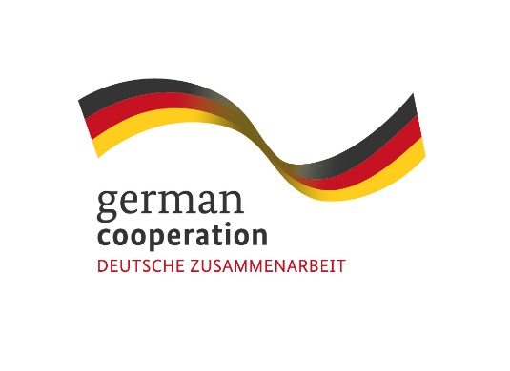
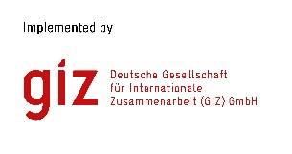
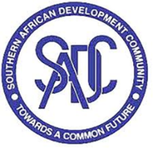

Contract 83423545

Invitation to tender advert: Development of Sustainability Plan and Business
Continuity Model for the SHOC

The Deutsche Gesellschaft für Internationale Zusammenarbeit (GIZ) GmbH supports the Southern African Development Community (SADC) Secretariat’s Disaster Risk Reduction (DRR) Unit through the SADC/GIZ Project “Global Initiative on Disaster Risk Management (GIDRM)” funded by the German Ministry of Economic Development and Cooperation (BMZ). The objective of GIDRM is to build capacities and skills of selected decision-makers and regional organizations and initiatives in Southern Africa and other global regions to enable the use of risk-informed development (RID) principles while taking account of context-specific fragility factors. To address the complex nature of risks and safeguard sustainable development, the GIZ through its Global Initiative on Disaster Risk Management (GIDRM), aims at strengthening risk governance and risk-informed development (RID) in the region
GIDRM in cooperation with the SADC Secretariats Disaster Risk Reduction Unit (DRR) are looking for consultancy services to develop a long-term Sustainability Plan inclusive of a Business Continuity Model for the SADC Humanitarian and Emergency Operations Centre (SHOC), that will enable the Centre to continue to fulfil its mandate in line with its vision and mission in a quest to provide Disaster Risk Management Coordination services to the region over time.
Submission deadline
Kindly submit your bid by email to BW_Quotation@giz.de no later than Thursday 24th of November 2022 17:00hrs, comprising of (i) a technical offer and (ii) price offer. Please note that tender bids received after the stipulated time, date will not be accepted.

Please note that this is a regional tender for SADC region-based companies only.

