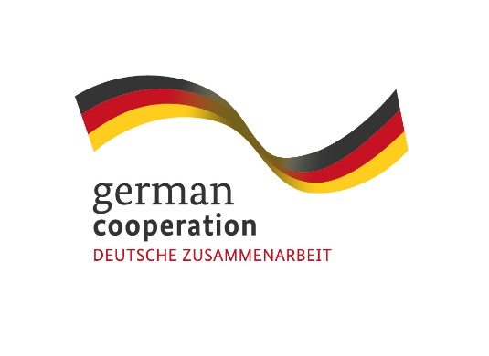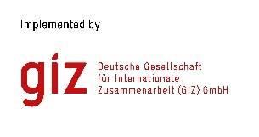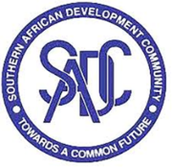

**Contract 83420652**

**CONSULTANCY ADVERT:** Support to the Training Component of the GIZ/SADC Climate Resilience and Natural Resource Management (C-NRM) project

The Deutsche Gesellschaft für Internationale Zusammenarbeit (GIZ) supports the SADC Food, Agriculture and Natural Resources (FANR) Directorate through the SADC/GIZ Project “Climate Resilience and Natural Resource Management” ([C-NRM](https://www.giz.de/en/worldwide/96082.html), 01/2021-12/2024) funded by the German Ministry of Economic Development and Cooperation (BMZ).

The overall objective of the C-NRM-Project is that climate change is systematically considered in cross-border Natural Resource Management (NRM) in the SADC region. The project has four outputs of which output 2 reads as: Dissemination of knowledge about climate-smart agriculture and climate-sensitive Natural Resource Management (NRM)/Ecosystem-based Adaptation (EbA) is strengthened.

It is under this output that the consultancy mainly seeks to support implementation of the following activities: - Identify new relevant regional training institutions and analyse their training offers and update/complement information on already inventorized institutions; and - Promote knowledge exchange between regional training institutions, research organizations/institutions, development projects in SADC TFCAs and funding institutions.

The required consultancy services are sought to technically support the C-NRM project team/advisors as well as the grant and financing agreement recipients in these above activities i.e. the Centre for Coordination of Agricultural Research and Development in Southern Africa (CCARDESA) and three regional consortia of training institutes.

The selected service provider will enter into a contract with GIZ.

**Submission deadline**

Kindly submit your bid, comprising (i) a technical offer and (ii) price offer **by 28 October 2022, 17.00hrs** by email submission at BW_Quotation@giz.de. Please note that tender bids received after the stipulated time, date will not be accepted.

**Please note that this is a regional tender for SADC region-based companies.**