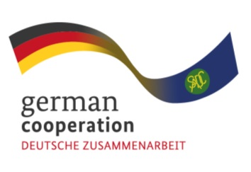
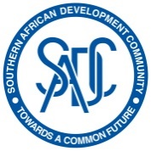

Contract: 83423425
Invitation to tender advert: Workshop facilitator to train Central Medical Stores (CMS) officials in the SADC Region on procurement best practices in the ARV value chain
The Southern African Development Community (SADC) Secretariat, the European Union (EU) and the German Federal Ministry for Economic Cooperation and Development (BMZ) are jointly supporting the “COVID-19-relevant Medical and Pharmaceutical Products” (CMPP), the Antiretroviral (ARV) and Leather regional value-chain (RVC) projects. These RVCs are part of the Joint Action “Support towards Industrialization and the Productive Sectors in the SADC region (SIPS) project. The overall objective of this assignment is to engage company that consists of 3 experts (1 facilitator and 2 trainers) to provide training and facilitation services to CMS officials in the region on relevant supply chain management topics and facilitate dialogue and the sharing of procurement best practices among the member states.
The SIPS inception phase conducted a detailed mapping analysis of the ARV value chain in the SADC region that uncovered that there are three (3) different routes to market ARV in the SADC region being donor market (largest market), public procurement by government through central medical stores (CMS) and the private market (insurance and out of pocket purchases). Central Medical Stores (CMS) are entities mandated to procure, warehouse and distribute pharmaceuticals such as ARVs in the public market. However, CMS`s in the region have been characterized by inadequate performance in procurement process due to different challenges such as inadequate human resources in number and in skills, inadequate product forecasting, poor information management and sharing, procurement not based on consumption data, lack of clear procurement guidelines, and poor partner coordination and duplication of efforts
The Joint Action SIPS aims to support Central Medical Stores in the SADC region who are the major buyers of ARVs in availing quality information to suppliers on their requirements and ensuring operational efficiencies as a way of ensuring that the private sector collaborates effectively with this segment of the market thereby enhancing the value chain. Findings from the inception phase of the ARV VC analysis revealed that there is a lack of market information data and working with Central Medical Stores on improving procurement processes is a step towards increasing market access by the private sector and enhancing internal processes of the Central Medical Stores.
The Joint Action SIPS is therefore inviting interested and qualified companies with their presence in the SADC region to apply for this regional assignment.
Submission deadline
Kindly submit your bid to BW_Quotation@giz.de no later than Wednesday 23rd November 20221700hrs, comprising of (i) a technical offer and (ii) price offer. Please note that tender bids received after the stipulated time, date will not be accepted.
Please note that this is a regional tender for SADC region-based companies only.

