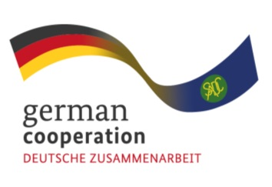

Call for Individual consultant Advert: 83418859
Needs Assessment for Electronic Procurement for the Lesotho National Drug Service Organisation (NDSO)

The Southern African Development Community (SADC) Secretariat, the European Union (EU) and the German Federal Ministry for Economic Cooperation and Development (BMZ) are jointly supporting the “COVID-19-relevant Medical and Pharmaceutical Products” (CMPP), the Antiretroviral (ARV) and Leather regional value-chain (RVC) projects. These RVCs are part of the Joint Action “Support towards Industrialization and the Productive Sectors in the SADC region (SIPS) project. The overall objective of this regional assignment is to support initiatives aimed at enhancing efficiency within Central Medical Stores of the SADC region with regards to information sharing with suppliers and execution of relevant procurement processes and in this case, conduct a needs assessment for implementation of electronic procurement, and build capacity in supply chain processes at the Lesotho National Drug Service Organisation (NDSO).

The public market, through government departments or Central Medical Stores are the major buyers of medical and pharmaceutical products, including ARVs. The Joint Action SIPS aims to support Central Medical Stores in the SADC region in availing quality information to suppliers on their requirements and ensuring operational efficiencies as a way of ensuring that the private sector collaborates effectively with this segment of the market thereby enhancing the value chain. Working with Central Medical Stores on improving procurement processes is a step towards increasing market access by the private sector and enhancing internal processes of the Central Medical Stores.

Findings from the inception phase of the Joint Action SIPS revealed that pharmaceutical manufacturers and suppliers lack market information and this initiative aims to increase access to information and ultimately market access by pharmaceutical manufacturers.

The Joint Action SIPS is therefore inviting interested and qualified individual consultants to apply for this regional assignment.
Submission deadline
Kindly submit your bid, comprising (i) a technical offer and (ii) price offer by Monday 26 September 2022,1700hrs by email submission at BW_Quotation@giz.de. Please note that tender bids received after the stipulated time, date will not be accepted.

