Providing Business Management Training  CONTRACT: 83416816 | Project number/  cost centre:  17.2034.1-010.00

0. List of abbreviations 2
1. Context 3
2. Tasks to be performed by the contractor 3
3. Concept 6
Technical-methodological concept 6
4. Personnel concept 7
5. Inputs of GIZ or other actors 7
6. Requirements on the format of the bid 8
7. Option 8

List of abbreviations
AVB General Terms and Conditions of Contract (AVB) for supplying services and work 2020
ARV Anti-Retroviral Value Chain
BMZ German Federal Ministry for Economic Cooperation and Development
CESARE Cooperation for the Enhancement of SADC Regional Economic Integration
CMPP COVID-19 relevant Medical and Pharmaceutical Products
EU European Union
RVC Regional Value Chain
SADC Southern African Development Community
SIPS Support towards Industrialisation and Productive Sectors
ToRs Terms of reference

Context
The Joint Action "Support towards Industrialisation and Productive Sectors" (SIPS) in the Southern African Development Community (SADC) region, is a SADC Secretariat programme supported by the European Union (EU) and the German Federal Ministry for Economic Cooperation and Development (BMZ) to facilitate the expansion of regional value chains (RVCs) and promote dialogue between the private and public sectors. The Joint Action SIPS is part of the BMZ-commissioned programme "Cooperation for the Enhancement of (SADC) Regional Economic Integration" (CESARE). The Joint Action SIPS comprising of three result areas commenced on 01 October 2019 and will run until February 2023. An extension until at least September 2023 is being processed. The SADC Secretariat administers the Result Area 1 (Enhancing policy, regulatory and business environment at national & regional levels for development & sustainable operation of regional value chains in the agro-processing and pharmaceutical sectors).The SADC Secretariat has chosen the German Development Agency, Deutsche Gesellschaft für Internationale Zusammenarbeit (GIZ), to implement Result Area 2 (Private Sector participation in regional pharmaceutical and medical value chains enhanced) and 3 (Private Sector participation in regional leather value chain enhanced).

The objective of the Joint Action SIPS is to contribute to the SADC industrialisation and regional integration agenda through improving the performance and growth of selected RVCs and related services within the agro-processing, pharmaceutical and medical products sectors. More specifically, the Joint Action aims to enhance private sector participation in the (1) Anti-retroviral (ARV) value chain, (2) COVID-19-relevant medical and pharmaceutical products value chain (CMPP), and (3) the regional leather value chain.
This assignment focuses on the Anti-Retroviral and Covid-19 relevant medical and pharmaceutical value chains.
The enhancement of business, entrepreneurial and subject matter knowledge skills is in both RVCs a key aspect of the interventions under the Joint Action SIPS, and in this respect, facilitating business management skill training is one of the key fields of the activities. By providing the training, the Joint Action SIPS aims to enhance the planning, coordination and organisation of participating company/organisation's business processes and activities to ensure maximum productivity and profitability. The Joint Action SIPS is cognizant of the resource limitations within the SADC region that the companies/institutions are operating in, therefore through this initiative it aims to ensure companies/organisations use limited resources (human, financial, material etc.) at their disposal, in an efficient manner to produce the most outputs. Overall, the aim is to embed the essential business management concepts into the company/organisation's systems and processes.

Tasks to be performed by the contractor
The overall objective of this regional assignment is to provide business management skills training for employees of companies included in the SADC region ARV and CMPP RVCs.
The contractor is responsible for providing the following deliverables:
- 4 virtual Business Management Skill Training short courses at an accredited institution over a contract time of 5 months (see overview figure below). The contractor should provide the following courses:
- 2 virtual Business Management Skills Training short courses for up to 25 participants per course on junior management level over a span of 5 days for each course.
- 1 virtual Business Management Skills Training short courses for up to 25 participants per course on middle management level over a span of 5 days for each course.
- 1 virtual Business Management Skills Training short course for up to 20 participants at senior management level over a span of 5 days.
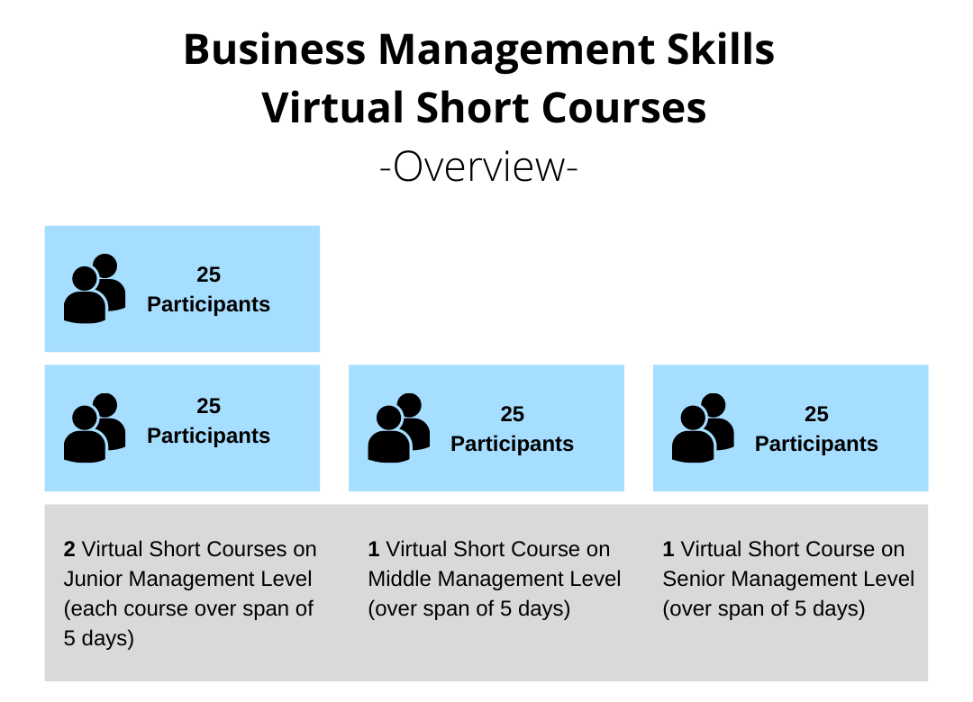
Figure 1: An overview of the Business Management Skills Virtual Short Courses

- Course Administration / Methodology:
- The contractor is responsible for enrolling the participants into the short courses. The Joint Action SIPS Team will provide names, contact information and availability of participants.
- The planning/scheduling of the courses will jointly be done with the SIPS team once the contract starts. This will allow flexibility on the contractor side, as well as for the participants. However, the contractor is responsible for offering a schedule that allows the 4 courses to take place before the end of the contract. In addition, the courses should be planned at least 4 weeks prior to course start, to allow the SIPS team to be able to contact participants on time as well as to allow participants to prepare and organise themselves.
- Each participant, who participates in the courses, shall receive a certificate at the end to prove their successful participation. The success shall be measured through attendance as well as a short test/ exam at the end of the course.

- Course Monitoring and Feedback:
- The contractor must provide a monitoring report after every implemented course (2-5 pages), which includes but shall not be limited to the following information: List of participants who registered for the course, list of participants who successfully finished the course (were provided a certificate), full documentation of course content.
- The contractor must conduct a detailed course feedback after each course, including feedback from the participants on the course content, structure and organisation, information on impact measurement, information on specific business management challenges the companies of participants are facing and specific further/ advanced business training needs of the participants. The information on impact measurement and feedback shall be jointly developed with the SIPS Team. The course feedback can be integrated into the monitoring report for each course.

- Course Content:
- All short courses should cover the same modules/topics (listed below) but should be delivered according to the skill levels of the participants (Junior, Middle and Senior Management Levels, as indicated above).
- The short courses should have a pharmaceutical and medical devices sector focus and use business case studies from that sector where applicable. Business case studies should be focussing on on experiences and challenges of the companies the participants are working in.
- Each course should include at least 5 of the following modules/topics but not limited to:
  - Leadership Management
  - Human Resource (People) Management
  - Financial Management
  - Business Environment and Economics (Micro and Macro)
  - Marketing Management
  - Operations and Supply Chain Management
  - Entrepreneurship
  - Strategic Management
  - Systems thinking
  - Innovation and Design thinking
  - Operational Effectiveness and Value-chain Analysis
  - Market access
  - Performance Management

- Course Delivery:
- All short courses should be implemented using the same methodology of teaching. The contractor must implement the short courses virtually and provide an appropriate online learning management system (LMS) e.g. Moodle, Blackboard, Google classroom.
- Course participants should be able to download the course material for at least one month after the course's end date free of charge.
- The short courses should consist of interactive online sessions and short assignments and can include a small amount of self-learning but not more than 10% of the course content.
- Course participants should be given the opportunity to approach the teacher during the course hours but also after the course in case they have questions.

- Course Language:
- All short courses should be taught in English. However, availability of courses in Portuguese and/or French would be beneficial.

- Teachers:
- All short courses should be taught by qualified teachers.
- As the participants are employed in the pharmaceutical and medical device sector in the SADC region, a sectoral expert should provide relevant input during the course sessions, to link the course content to real-life experiences.

Certain milestones, as laid out in the table below, are to be achieved by certain dates during the contract term, and at particular locations:
Milestone | Deadline/place
- Draft proposal for course curriculum content | 2 weeks after contract starts
- Finalization and agreement with SIPS team on course curriculum content | Until one month after contract starts
- 2x Business Management Skill Course on Junior Management Level (each course 5 days) implemented | Until 28 February 2023/ place: virtual
- 2x Monitoring and Feedback Report for Junior Management Course | Latest 3 weeks after the course ends
- 1x Business Management Skill Course on Middle Management Level (each course 5 days) implemented | Until 28 February 2023/ place: virtual
- 1x Monitoring and Feedback Report for Middle Management Course | Latest 3 weeks after the course ends
- 1x Business Management Skill Course on Senior Management Level (5 days) implemented | Until 28 February 2023/ place: virtual
- 1x Monitoring and Feedback Report for Senior Management Level | Latest 3 weeks after the course ends

Period of assignment: From October 2022 until 28 February 2023. The assignment days are 28 person-days (4 courses x 5 days per course, including days for preparation, reporting and briefing).

Concept
In the bid, the bidder is required to show how the objectives defined in Chapter 2 are to be achieved, if applicable under consideration of further specific method-related requirements (technical-methodological concept).

Technical-methodological concept
Strategy: The bidder is required to consider the tasks to be performed with reference to the objectives of the services put out to tender (see Chapter 1). Following this, the bidder presents and justifies the strategy with which it intends to provide the services for which it is responsible (see Chapter 2).
- For the different course modules, the bidder is required to provide a detailed description of the course, including the modules, learning outcomes and their detailed content based on the module list provided in chapter 2.
- For the course teaching method, the bidder is required to provide a detailed description of how the requested method mentioned in chapter 2 will be implemented.
- The bidder is required to provide the CVs of the course teachers.
- For the course administration, the bidder is required to describe the online platform for the courses, including its accessibility in the SADC region.
- For the course monitoring and feedback, the bidder is required to describe in detail how the feedback is being conducted from the participants and presented to the SIPS team.
The bidder is required to present the sectoral experts (e.g. pharmaceutical and medical devices sector experts) relevant for the services for which it is responsible and describe the cooperation with them.
- The bidder is required to describe in detail how the interaction with course participants take place, e.g. follow-up on assignments, questions by the participants, registration, interaction on the online platform.
- The bidder is required to describe in detail how sectoral experts will be integrated into the course outline.
The bidder is required to describe the key processes for the services for which it is responsible and create a schedule that describes how the services according to Chapter 2 are to be provided. In particular, the bidder is required to describe the necessary work steps and, if applicable, take account of the milestones in accordance with Chapter 2.
Other specific requirements
– Not applicable –
Project management of the contractor
– Not applicable –

Personnel concept
– Not applicable –

Inputs of GIZ or other actors
GIZ and/or other actors are expected to make the following available:
- Names and contacts of course participants.
- Schedules/availability of course participants.
- Questions for the impact measurement, which will be included into the course monitoring reports.

Requirements on the format of the bid
The structure of the bid must correspond to the structure of the ToRs. In particular, the detailed structure of the concept (Chapter 3) is to be organised in accordance with the positively weighted criteria in the assessment grid (not with zero). It must be legible (Arial font size 11, line spacing of 1.15 and all margins 1 inch) and clearly formulated. The bid is drawn up in English (language).
The complete bid shall not exceed 20 pages (excluding CVs).
If one of the maximum page lengths is exceeded, the content appearing after the cut-off point will not be included in the assessment.
As the contract to be concluded is a contract for works, please offer a fixed lump sum price that covers all applicable costs.The price bid will be evaluated based on the specified lump sum price. For our internal costing and any further commissions, please also provide the cost structure/breakdown on which the prices are based on, taking into account the modules offered, the management level and the total course duration.

Option
After the tasks put out to tender have been completed, important elements of these tasks can be continued or extended within the framework of a follow-on assignment. Individual points:
- Type and scope: The option includes 3 additional business management skill courses, same design, number of participants per course and methodology as described above. 1 course will be on junior management level and 2 courses will be on middle management level (see detailed course description in chapter 2). The option includes a contract extension of additional 6 months.
- Requirements: The option becoming effective is subject to the results of the original contract.
The option is exercised in the form of an extension to the contract based on the already offered individual rates.

