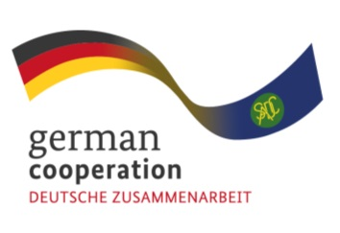

CONTRACT 83416816
CONSULTANCY ADVERT FOR THE JOINT ACTION SIPS BUSINESS MANAGEMENT SKILLS TRAINING
The Southern African Development Community (SADC) Secretariat, the European Union (EU) and the German Federal Ministry for Economic Cooperation and Development (BMZ) are jointly supporting the “COVID-19-relevant Medical and Pharmaceutical Products” (CMPP), the Antiretroviral (ARV) and Leather regional value-chain (RVC) projects. These RVCs are part of the Joint Action “Support towards Industrialization and the Productive Sectors in the SADC region (SIPS) project. The overall objective of this regional assignment is to provide business management skills training for employees of companies included the SADC region ARV and CMPP RVCs.

The enhancement of business, entrepreneurial and subject matter knowledge skills is in both RVCs a key aspect of the interventions under the Joint Action SIPS, and in this respect, facilitating business management skill training is one of the key fields of the activities. By providing the training, the Joint Action SIPS aims to enhance the planning, coordination and organisation of participating company/organisation's business processes and activities to ensure maximum productivity and profitability. The Joint Action SIPS is cognizant of the resource limitations within the SADC region that the companies/institutions are operating in, therefore through this initiative it aims to ensure companies/organisations use limited resources (human, financial, material etc.) at their disposal, in an efficient manner to produce the most outputs. Overall, the aim is to embed the essential business management concepts into the company/organisation's systems and processes.

The Joint Action SIPS is therefore inviting interested service providers/companies based in the SADC region to apply for this regional assignment.

Submission deadline
Kindly submit your bid, comprising (i) a technical offer and (ii) price offer by 19th September 2022, 17.00hrs by email submission at BW_Quotation@giz.de. Please note that tender bids received after the stipulated time, date will not be accepted.

