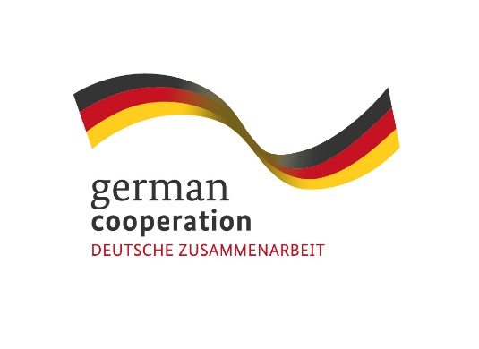
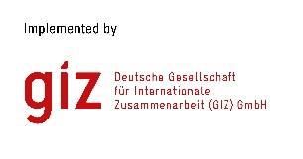

Call for Proposals: Supporting the Preparation of national EPA Monitoring Reports by SADC EPA Member States.
Contract 83414339

The Deutsche Gesellschaft für Internationale Zusammenarbeit (GIZ) GmbH, through its project “Supporting sustainability aspects in the implementation of EU Economic Partnership Agreements”, commissioned by the German Federal Ministry for Economic Cooperation and Development (BMZ), cordially invites interested and qualified consulting firms to send in a proposal: Supporting the Preparation of national EPA Monitoring Reports by SADC EPA Member States.
Following the signature of the Economic Partnership Agreement (EPA) between six (6) SADC Member States (Botswana, Eswatini, Lesotho, Mozambique, Namibia and South Africa) on the one hand, and the European Union (EU) on the other and its provisional application since October 2016, GIZ commenced a global project operating under the title “Supporting sustainability aspects in the implementation of EU Economic Partnership Agreements (NEW)”. The overall objective of the project is to foster EPA implementation by regional organisations, their member states, the private sector and civil society in a way that supports sustainable development. Its geographical focus is on Southern Africa (SADC EPA), Eastern and Southern Africa (ESA) and the Caribbean (CARIFORUM EPA).
The objective of this initiative is to technically support three SADC EPA Member States in the collection and analysis of monitoring data and the preparation of their national EPA monitoring reports. The reports, when eventually finalized by the SADC EPA States and submitted to the SADC EPA Unit, will feed into the regional consolidated monitoring report and subsequently any joint monitoring report as agreed by the parties to the EU-SADC EPA
Submission deadline
Kindly submit your bid, comprising (i) a technical offer and (ii) price offer by 22nd August 2022,15.00hrs by email submission at BW_Quotation@giz.de. Please note that tender bids received after the stipulated time, date will not be accepted.

Please note that this is a regional tender for SADC region-based companies.

