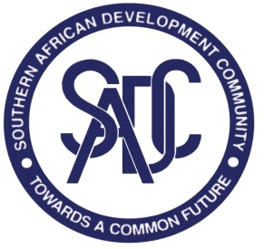

SPECIFIC PROCUREMENT NOTICE

CONSULTANCY FOR IMPLEMENTATION OF MICROSOFT SHAREPOINT AT THE SADC SECRETARIAT

REQUEST FOR PROPOSALS

Reference Number: SADC/ICT/CONSULTANCY/01/2017
Procurement entity: SADC SECRETARIAT

Number and titles of lots: 1

Location: SADC Secretariat, Western Commercial Road (near Lobatse and Siboni Roads), CBD Plot 54385,Private Bag 0095, Gaborone, BOTSWANA.

- The Southern African Community (SADC) Secretariat has set aside funds for the operation of the Secretariat during the financial year 2016/17. It is intended that part of the proceeds of the fund will be used to cover eligible payments under the Consultancy contracts for the Implementation of Microsoft SharePoint at the SADC Secretariat.

- The SADC Secretariat now invites sealed proposals from eligible and reputable consulting firms interested to bid for the Assignment

- The procurement method used for this contract is Quality and Cost Based Selection under the Open Bidding as defined in the revised SADC Secretariat Procurement Policy and Guidelines available at the following website: www.sadc.int

- The RFP can be obtained from the following website: http://www.sadc.int/opportunities/procurement/open-procurement-opportunities/
- The closing time and date for submission of the proposals at the address indicated in the RFP document is 10th February at 15:00hrs local time. Proposals received after this time and date, or submitted otherwise than indicated in the RFP Document shall not be considered and shall be returned unopened.

- The procurement opportunity is open to all companies/firms which satisfy the eligibility and qualification requirements stated in the RFP

- All notifications concerning this procurement process, including: or cancellation notices, Requests for clarification and the respective responses will be published on the following website: www.sadc.int

- Interested companies/firms may seek clarification or/and additional information concerning this Request for proposal, only in writing (or by email) and by latest 16:00hrs on 20th January 2017 from the following contact points:

Head of Procurement
Southern African Development Community (SADC) Secretariat
CBD Plot 54385
Room DGP11 on Ground Floor
City: Gaborone
Country: Botswana
Phone: +2673951863
Fax: +2673972848/3181070
Email: ggwaza@sadc.int
Attention: Mr. Gift Mike Gwaza

With copy to: rlekhanya@sadc.int
Attention: Mr. Ramoletane Lekhanya,

