

NEGOTIATION PROCEDURE REQUEST FOR BIDS (RFB)

**Reference Number*:*** SADC/ICT/2/2020

**Title**: **SUPPLY OF SOFTWARE LICENCES, RENEWALS AND CISCO SMARTNET**

Number of Lots: **5**

1. **SADC Secretariat** is inviting ***product partners*** and ***authorised*** resellers ***only*** to submit a bids for the Supply of the following items

|  |  |  |
| --- | --- | --- |
| **Lot** | **Item** | **Qty** |
| 1 | Renewal only:  F-Secure Licences and support (12 months effective 8 Jan 2021) | **350 client**  **60 server** |
| 2 | Renewal only:  Solarwinds Licences and support (12 months effective Dec 22 2020) | **7 modules** |
| 3 | Renewal only:  PaperCut MF licences and support (12 months Effective 10 Feb 2021) | **23 devices** |
| 4 | Veeam Backup and replication Software Licence and support (12 months effective Feb 13, 2021). See details in annex 1. | **10 sockets (annual basic renewal)**  **10 (new) sockets** |
| 5 | Cisco Smart Net Total Care (12 months effective 1 November 2020) | **1** |

1. You should send only **one bid** for this requirement. **Bidders may bid for one or more lots and the total prices should be expressed per lot.**

**IMPORTANT : INCLUDE ALL RELEVANT DOCUMENTATION BELOW:**

* 1. **The Certificate of Incorporation**
  2. **The Trading License**
  3. **Valid Tax Clearance Certificate**
  4. **The PPADB Certificate**
  5. **Banking details**
  6. **Company Profile**

1. Your **bid** should be titled as shown below and addressed to:

“**SUPPLY OF SOFTWARE LICENCES, RENEWALS AND CISCO SMARTNET**".

*Head – Procurement unit SADC Secretariat*

*Plot 54385 CBD*

*Gaborone BOTSWANA*

**Late submissions and faxed quotations are not acceptable**

Bids should be emailed to the following email address: [ictrenewal2020@sadc.int](mailto:ictrenewal2020@sadc.int)

1. The deadline for submission of your bids, to the email addresses indicated in Paragraph 3 is: **Monday 19th October 2020; 14:30hrs.**
2. Your bids should be submitted as per the following instructions, and in accordance with the Terms and Conditions of the Standard Purchase Order for SADC which is available on request.
   1. PRICES: The prices should be convertible to the local Pula currency (Include exchange rate to Pula if using foreign currency), including all duties attached to the sale of the ***goods*** (such as VAT, customs duties, etc) and transport to the final destination.
   2. EVALUATION AND AWARD OF PURCHASE ORDER: Bids determined to be administrative (see Paragraph 2,3,4 and 5 and technically compliant to the requirements will be evaluated by comparison of their prices per lot (defined as above). The award will be made to the bidder offering an administratively and technically compliant quotation at the lowest total price for the lot.

(iv) VALIDITY OF THE OFFER: Your Bid should be valid for a period of 90 days from the date of deadline for submission of quotation indicated in Paragraph 4 above.

6. The software ***licenses*** are expected to be delivered within ***2weeks*** from the signature of the Purchase Order.

**7.** Additional information and clarifications can be requested **n writing**, via email addresses below no later than **Wednesday 14th October 2020; 16.30hrs.**

*Email:* [ictrenewal2020@sadc.int](mailto:ictrenewal2020@sadc.int); cc: [*tlengoasa@sadc.int;*](mailto:tlengoasa@sadc.int) *cc:* [*clungu@sadc.int;anguni@sadc.int*](mailto:clungu@sadc.int;anguni@sadc.int)

***during working hours.***

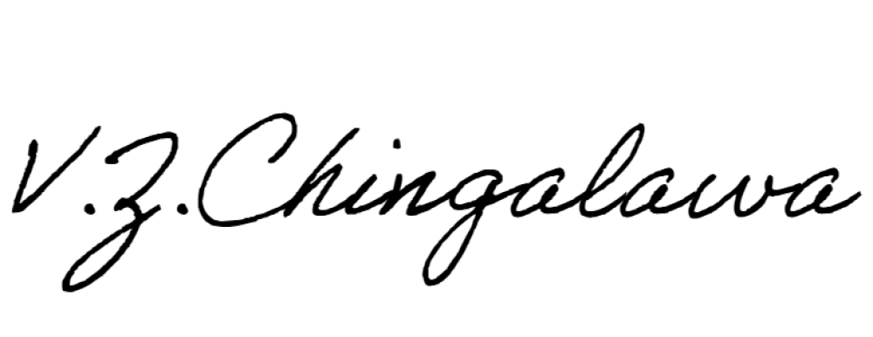**Sincerely,**

**Name: Mrs Veronica Chingalawa**

**Title: Acting Senior Officer - Procurement Date: 22nd Sept 2020**

**ANNEX 1 TECHNICAL SPECIFICATIONS**

**LOT 1: F-Secure partners and authorized resellers only (attach evidence)**

|  |  |  |  |
| --- | --- | --- | --- |
| **Lot**  **N°** | **Project** | **Description** | **Qty** |
| **1** | FCCPSR1NVXCIN | F-Secure Client Security Premium Subscription - Renewal for 1 year (100-499) | 350 |
| FCSPSR1NVXBIN | F-Secure Server Security Premium Subscription - Renewal for 1 year (25-99) | 60 |
| ISA-S01-SA11 | ISA Annual Service - Access Silver 8/5 Including Unlimited telephonic and email support and 30x Time Units to be used  typically for remote support, investigation and remediation | 1 |

**LOT 2: Solarwinds partners and authorized resellers only (attach evidence)**

|  |  |  |
| --- | --- | --- |
| LOT | **Modules** | **Qty** |
| 2 | SolarWinds Web Help Desk Per Seat License (6 to 10 named users) - License with 1st-Year Maintenance (Annual Maintenance Renewal) | 10 |
| SolarWinds Security & Event Manager SEM30 (up to 30 nodes) - Annual Maintenance Renewal | 1 |
| SolarWinds Server & Application Monitor AL150 (up to 150 monitors) - Annual Maintenance Renewal | 1 |
| Server Configuration Monitor SCM10 (up to 10 Managed Servers) License with 1st-Year Maintenance (Annual Maintenance Renewal) | 1 |
| SolarWinds Network Performance Monitor SL250 (up to 250 elements) - Annual Maintenance Renewal | 1 |
| SolarWinds Network Configuration Manager DL50 (up to 50 nodes)- Annual Maintenance Renewal | 1 |
| Solarwinds Kiwi Log Server (Annual Maintenance Renewal) | 3 |

**LOT 3: Papercut partners and resellers only (attach evidence)**

|  |  |  |  |
| --- | --- | --- | --- |
| **Lot**  **N°** | **Project** | **Description** | **Qty** |
| 3 | ICT | Renewal of Support (Upgrade Assurance) for Paper Cut MF printer management software.  Customer Details: Support ID: PS107815-3565 Licensed Version: 16  Company: Southern African Development Community. Licensed for: 400 users | 23 |

|  |  |  |  |
| --- | --- | --- | --- |
|  |  | Total Licensed Devices: 23  Renewal Period: 12 Months effective December 2020(1 Year) Licensed modules: Print Control Module • Internet Control  Module Paper Cut Approved Reseller Details: Symbiosis: Ema[il: info@symbiosis.co](mailto:info@symbiosis.co) |  |

**LOT 4: Veeam partners and resellers only (attach evidence)**

|  |  |  |
| --- | --- | --- |
| **Product Code** | **Description** | **Qty** |
| **V-VBRENT-VS- P01AR-00** | Annual Basic Maintenance Renewal -  Veeam Backup & Replication Enterprise  New Support Period: February 14,  2021 - February 13, 2022 | **10** |
| **V-VBRENT-VS- P0000-00** | Veeam Backup & Replication Enterprise. Includes 1st year of Basic  Support (additional sockets) | **10** |
| **V-VBRENT-VS- P01MR-00** | Monthly Basic Maintenance Renewal -  Veeam Backup & Replication Enterprise | **12** |
|  | Co-term New licenses with Existing SADC Contract (02091576) to end on February 13, 2022 |  |

**LOT 5: CISCO SMART NET COVER (Cisco partners only. Attach evidence)**

|  |  |  |  |
| --- | --- | --- | --- |
| Item  No | Project | Description | Qty |
| a | ICT Unit | Cisco Smartnet equipment renewal for 12 months  Past cisco contract ID: 202679939  **Important: (List and include all items covered in quote. See**  **annex 2 for list of equipment)** | 1 |

**ANNEX 2**

**REFER TO THE CISCO EQUIPMENT EXCEL DOCUMENT ATTACHMENT**