

NEGOTIATED PROCEDURE
REQUEST FOR BIDS (RFB)

Reference Number: SADC3/5/1/35

RFB Title: SUPPLY AND DELIVERY OF OFFICE FURNITURE, CAMPING CHAIRS & FITTING OF SHELVING RACKS FOR SADC SECRETARIAT

Dear Sir/Madam,

- The SADC Secretariat now invites proposals to provide the following; SUPPLY AND DELIVERY OF OFFICE FURNITURE, CAMPING CHAIRS & FITTING OF SHELVING RACKS FOR SADC SECRETARIAT
More details on the goods are provided in the attached Terms of Reference.

Bidders are allowed to quote for one or a combination of lots. that bidders are to quote for all items in a lot failure to do that will render the bid for that lot non-responsive

R
- The Bidding Documents have been allocated into Lots as follows:

- LOT: 1 – SUPPLY AND DELIVERY OF OFFICE FURNITURE FOR SADC SECRETARIAT -35206
- LOT: 2 – SUPPLY AND FIT OF SHELVING RACKS FOR SADC SECRETARIAT – 39028
- LOT: 3 - SUPPLY AND DELIVERY OF SADC BRANDED CAMPING CHAIRS - 30144

Technical Specifications for: SUPPLY AND DELIVERY OF OFFICE FURNITURE, CAMPING CHAIRS & FITTING OF SHELVING RACKS FOR SADC SECRETARIAT
(See detailed under Annex 1 below)

- Your submission, in the PDF format (See Annex 2 to this RFB), should be submitted in PDF Format to the following email: furchair22@sadc.int bearing the Lot Number and subject title you have quoted for
SADC3/5/1/35
SUPPLY AND DELIVERY OF OFFICE FURNITURE, CAMPING CHAIRS & FITTING OF SHELVING RACKS FOR SADC SECRETARIAT

Attention: Mr. Mr Purpose Chifani

4. The deadline for submission of your quotations, to the address above is Monday 14th March 2022 at 14:00 hours local time. Late submissions will not be accepted.

- All bids should be submitted in PDF format to the following email: furchair22@sadc.int and quotations by fax will NOT be accepted.

- Your bid(s) should be submitted as per the following instructions, and in accordance with the Terms and Conditions of the Standard Purchase Order.:

- PRICES: The prices should be quoted CIP (as per Incoterms 2010) in the local currency Botswana Pula(BWP), including all duties attached to the sale (such as VAT, customs duties, etc.) and transport to the final destination.
- EVALUATION AND AWARD OF PURCHASE ORDER: Bids determined to be administratively (see Paragraph 2, 4, 5 and 6) and technically compliant to the requirements will be evaluated by comparison of their prices (defined as above). The award will be made to the bidder offering an administrative and technical compliant quotation at the lowest evaluated total price.
- VALIDITY OF THE OFFER: Your quotation should be valid for a period of 90 days from the date of submission of quotation.
- DOCUMENTS TO BE ATTACHED: Company Profile, Valid Tax Clearance Certificate, Banking Details, Valid Trading Licence and Certificate of Incorporation, Valid VAT Certificate or Exemption Certificate
- DELIVERY TIME AND STOCK AVAILABILITY: Bidders must indicate delivery period and stock availability.
6. The items are expected to be delivered at the address indicated in the Paragraph 3 above within 14 calendar days from the signature of the Purchase Order/Contract. The terms and conditions of the Purchase Order are available on request prior to submission of quotations.

7 Additional request for information and clarifications can be made, no later than 10 days prior to deadline indicated in the paragraph 4 above, from: 01st March 2022 14:00 hours local time
The deadline for responding to Request for clarification is 04th March 2022
Procuring entity: SADC Secretariat
Contact person: Mr. Purpose Chifani
Telephone: +2673951863
Fax: +2673971787

E-mail: pchifani@sadc.int; tenders@sadc.int

Copy; hmaripe@sadc.int

ANNEXES:
ANNEX 1: Technical Specifications
ANNEX 2: Bid Form

Sincerely,

Purpose Chifani
Ag. Senior Officer - Procurement
21st February 2022
ANNEX 1.

MINIMUM TECHNICAL SPECIFICATIONS FOR
SUPPLY AND DELIVERY OF OFFICE FURNITURE, CAMPING CHAIRS & FITTING OF SHELVING RACKS FOR SADC SECRETARIAT

LOT: 1 – SUPPLY AND DELIVERY OF OFFICE FURNITURE FOR SADC SECRETARIAT-35206

Item No. | Description | Quantity | Picture |  | COMPLIANCE  (Yes/No)
1. | Executive Boardroom Chairs  Soft Vis Executive Chair (genuine Black Leather)  Swivel Tilt Mechanism  High Back  Chrome Loop arms with 5 Star Base (Chrome/Aluminum)  Adjustable Arm Rests  Synchronized mechanism  Quantity - 12 | 12 | 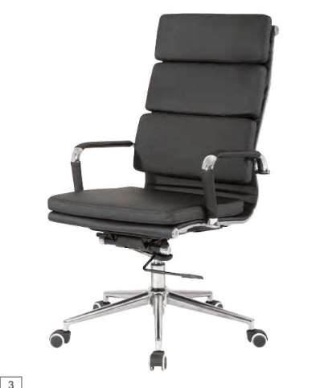
2. | Swivel Chairs  Round padded Nylon Base  Swivel and tilt mechanism  Adjustable Lumbar Support  Polyurethane arms  Fixed arm rest  3D mesh upholstery in black  Gas Height adjustment  Head rest  High back  Quantity – 130 | 130 | 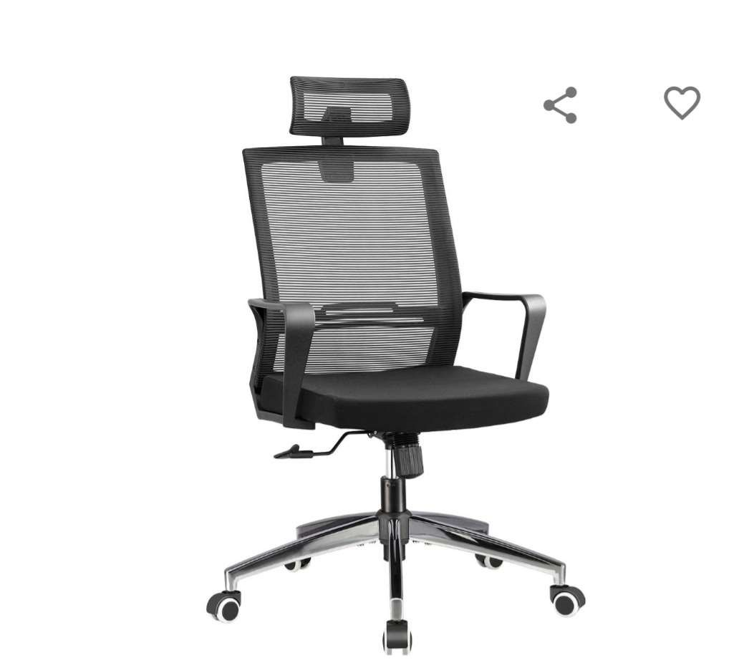
OVERAL SCORE: Compliant / non-compliant

LOT: 2 – SUPPLY AND FIT OF SHELVING RACKS FOR SADC SECRETARIAT- 39028

Item | Project | Minimum Specification | Quantity | Compliance  (Yes/No)
1 | SHELVING RACKS | Steel shelving inserted with strong pallet shelves.  Each unit to measure 1105mm left to right x 475mm front to back with 7 shelves to a height of 2134mm.  Each shelf has a uniformly distributed safe working load of 100kg.  Supply and fitting | 45
OVERAL SCORE: Compliant / non-compliant

LOT 3: SUPPLY AND DELIVERY OF SADC BRANDED CAMPING CHAIRS - 30144

# | Description | Qty | Compliance  (Yes/No)
1. | Homcosan Portable Camping Chair Folding Quad Outdoor Large Heavy Duty Support 330 lbs Thicken 600D Oxford with Padded Armrests, Storage Bag, Beverage Holder, Navy Blue and Reflex Blue Colour, Carry Bag for Outside (Blue), Branded with SADC logo and website, screen printed front and back.  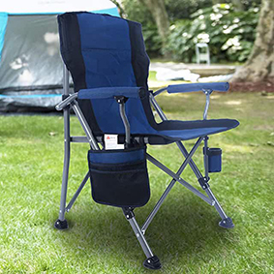 | 50
2. | Homecall 30115 camping Folding chair 600D polyester /rip stop with side pocket grey blue, 95.0 cm*55.0 cm*55.0 cm, Polyester, branded with SADC logo and website, screen printed front and back.  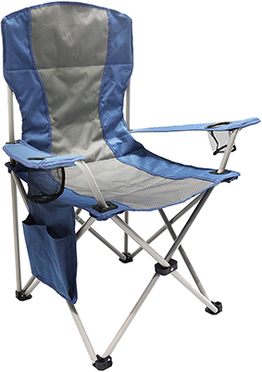 | 220
OVERAL SCORE: Compliant / non-compliant

ANNEX 2.
BID FORM

Technical Specification | Delivery period to SADC Secretariat  in weeks from the signature of the PO | Quantity | Unit price CIP at SADC HQ | Total price CIP at SADC HQ
 |  |  | [insert the price] | [insert the price]
Subtotal 1
VAT
Grand TOTAL | [insert the end of all deliveries] |  |  | [insert the grand total price]

Once corrections or adjustments have been applied, the Financial Proposal shall be adjusted with the Regional Preference

The Procuring Entity shall grant a margin of preference in the evaluation of bids from companies from the SADC Region when compared to bids from elsewhere.
The margin of Prefence shall be calculated as a Maximum fifteen percent (15%) discount to the evaluated total price.
In case of a Consortium, the quality for the Regional and the companies providing at least 50% of the goods offered must be from the Region.

The final Selection for SUPPLY AND DELIVERY OF OFFICE FURNITURE, CAMPING CHAIRS & FITTING OF SHELVING RACKS FOR SADC SECRETARIAT will be based on the lowest quoted price per lot. This selection will be from those who would have passed the Technical Stage.

