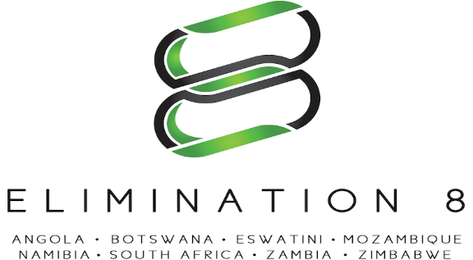

JOB DESCRIPTION

JOB TITLE | Knowledge Management Specialist | LOCATION | Windhoek, Namibia
REPORTING TO | Head of Technical Support and Research | LENGTH OF CONTRACT | 9 months
ROLE TYPE | International | DIRECT REPORTS | NA
TRAVEL INVOLVED | 40% | Grade | C

Organisational background

The Elimination 8 (E8) regional initiative, formed in 2009, was established under the auspices of the Southern Africa Development Community (SADC) to provide a platform for coordinating regional E8 malaria elimination efforts. The E8 aims to accelerate zero local transmission in four low transmission “frontline countries”— Botswana, Eswatini, Namibia, and South Africa — by 2020, and to pave the way for elimination in four middle- to high-transmission “second line countries”— Angola, Mozambique, Zambia, and Zimbabwe — by 2030, through enhanced collaboration and coordination. Specifically, it has the following mandate:

- To strengthen regional coordination in order to achieve elimination in each of the E8 member countries;
- To elevate and maintain the regional elimination agenda at the highest political levels within the E8 countries;
- To promote knowledge management, quality control, and policy harmonization to accelerate progress towards elimination;
- To facilitate the reduction of cross-border malaria transmission; and
- To secure resources to support the regional elimination, plan, and to ensure long term sustainable financing for the region’s elimination ambitions.

JD overview

The Knowledge Management Specialist is responsible for coordinating and promoting knowledge uptake and evidence-based decision making across the Region. The incumbent will offer advice and guidance as to how the E8 can promote, utilize, and share best practices and relevant knowledge, with an emphasis on cutting edge new evidence. He/she is expected to collect, curate knowledge, and share it widely to enhance innovation, efficiency, and effectiveness in program implementation, and improve organizational performance. The Specialist will work internally with management and staff and externally with Centre’s of Excellence and other stakeholders and partners within the Region and beyond.

Key Results Areas
Facilitate Regional Knowledge Management and best practices
- Work proactively with the E8S team to identify opportunities for capturing and sharing relevant new knowledge, its translation into practice and the dissemination of information;
- Establish E8 footprint on the Global Knowledge platforms to increase access to technical knowledge, stimulate innovation and behaviour change and support policy and decision making with appropriate evidence;
- Document and share programmatic best practices and lessons learnt;
Technical Collaboration with National Malaria Control Programs and Partners
- Develop, publish, and disseminate knowledge products such as factsheets, testimonials, success stories, publications on lessons learnt, videos, how-to-guides and best practices guides; and
- Develop a Standard Operating Procedures to guide knowledge gathering, sharing and dissemination;
- Facilitate the transfer of lessons and research evidence into practice and policy;

Support Regional Capacity Building
- Develop a knowledge management and capacity strengthening strategy and action plan for E8. The strategy will identify the target group, sources of knowledge and knowledge holders, key topics to be addressed, products to be developed and dissemination channels;
- Support knowledge management, knowledge dissemination and capacity strengthening events and activities across the Region.
- Conduct a needs and capacity assessment in the identified knowledge target group

Required qualifications
- Master’s degree in Knowledge Management, Information Science, Data Science, or any other related field.
- Master’s degree in Public Health will be an added advantage.
Experience
- At least 5 years relevant experience in Knowledge management and learning, or related field;
- Solid understanding of translating researched or published documents into policy, including Malaria elimination issues; and
- Experience in developing and implementing knowledge and learning initiatives, with a solid understanding of the related principles, tools and products.
Language Skills
- Fluency in English (verbal and written) is essential.
Competencies
Functional competencies:

- Good data and information compilation skills;
- Good understanding of public health data management;
- Good communication skills;
- Ability to act and organise in a dynamic multi-disciplinary environment;
- Ability to be innovative and to think-out of the box;
- Ability and willingness to rapidly learn and assimilate new information, skills and knowledge;
- Proven integrity and work ethics and be able to independently executive roles assigned; and
- Ability to pay attention to detail.
Corporate competencies:

- Strong knowledge / experience in results-based management and results-oriented approach to project implementation;
- Strong networking, interpersonal, communication and team building skills;
- Produce quality outputs, timely and ethically;
- Demonstrated ability to analyze, synthesize complex, multi-disciplinary technical and peer-reviewed information; and
- Ability to develop high quality capacity building strategies and knowledge sharing platform.

