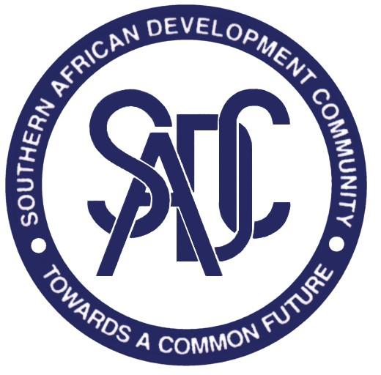

COMMUNITY SECRETARIAT SECRETARIAT
SOUTHERN AFRICAN DEVELOPMENT

Private Bag 0095 E-mail: registry@sadc.int Telephone: (267) 3951863
Gaborone Website: www.sadc.int Telefax: (267) 3972848
Botswana (267) 3181070

SADC Annual Quality Awards 2013

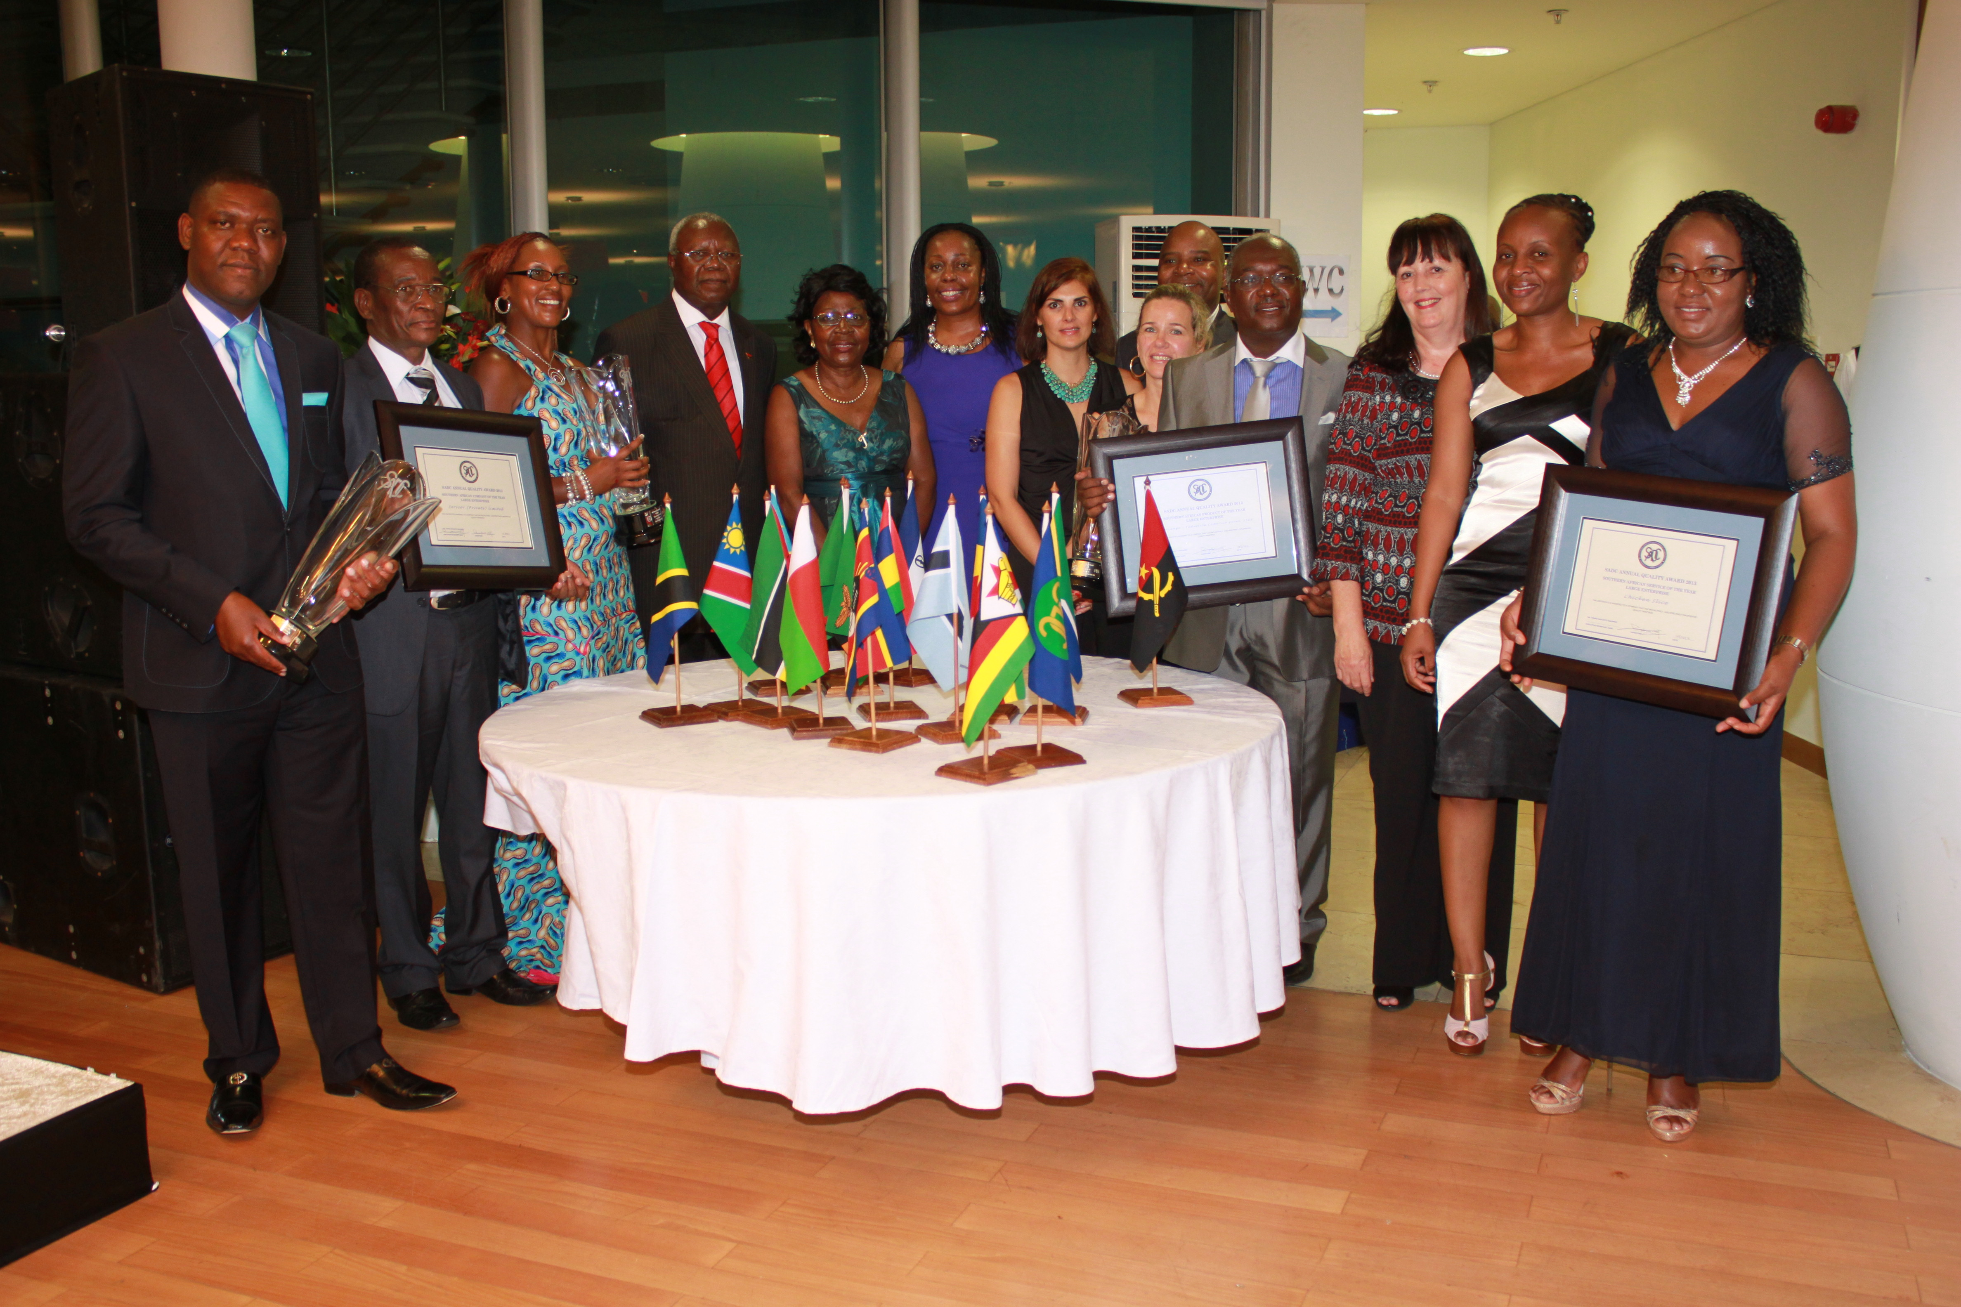

Winners of the SADC Annual Quality Award 2013: From the left: Representatives from Chicken Slice, representatives of Servcor (Private) Limited, Secretary of State for Industry His Excellency Kiala Gabriel, Director General of Angola Institute of Standardisation and Quality (IANORQ), Director General Standards Association of Zimbabwe (SAZ) , representatives from Regriango, representatives from SADC Secretariat and the SQAM Expert Group (SQAMEG) Chairperson.

The third SADC Annual Quality Awards presentation ceremony was held on the evening of the 20th March 2013 in Luanda, Angola during the SADC Standardisation, Quality Assurance, Accreditation and Metrology (SQAM) Annual meetings for 2013. The awards ceremony was held at a prestigious event in the Complexo Turistico Paz Flor, Luanda, Angola. The presentation ceremony was graced with the presence of His Excellency the Secretary of State for Industry, Kiala Gabriel. The 2013 winning companies and categories are; Servcor (Private) Limited a company from Zimbabwe was the winner in the Large Enterprise Southern African Company of the year, Regriango – Industria Comercio Geral, Ltda a company from Angola winning the Large Enterprise Southern Africa Product of the year and Packers International (Private) Limited trading as Chicken Slice another company from Zimbabwe winning in the Large Enterprise Southern African Service of the year.

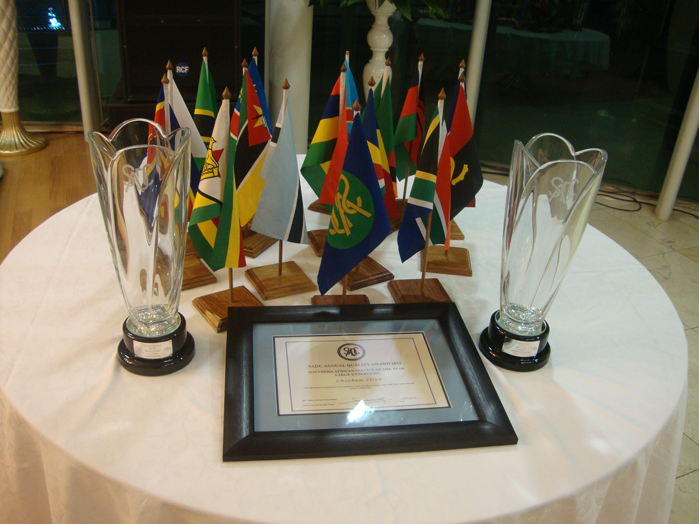

Trophies and Certificates awarded.

These companies were recognized for having robust quality management systems that have demonstrably contributed to the growth of their businesses. In his remarks, His Excellency Kiala Gabriel indicated that the SADC Annual Quality Awards Procedure provides descriptions of the essential features, characteristics and approaches of organisational systems that promote sustainable and excellent performance. He further highlighted that the SADC Annual Quality Awards provides SADC with a platform and an opportunity to encourage local industries to be aware of quality issues, cognisant of the fact that success of our services and products in local markets due to excellent quality and reasonable price translating in to guaranteed success in regional and international markets as well. He emphasised that the competition increases awareness on the importance of a quality culture, use of international standards and interest in quality management because of their contribution to product competitiveness.

In his remarks he noted the progress made so far in the implementation of the SADC Annual Quality Awards Procedure. He expressed his delight in the fact that all winners were present in this year presentation to receive their own trophies and certificates.

All Member States are encouraged to facilitate more private and public sector involvement in the SADC Annual Quality Awards; noting that the national level competitions form the basis for the regional competitions.

For more information: March 26, 2013

Kuena Molapo (Ms)
Programme Officer – SQAM
Trade and Industry, Finance and Investment Directorate
Mobile: +267 72577926
Tel : +2673641653

Email: kmolapo@sadc.int; kuena24@yahoo.co.uk

